Activity Service Manual Version 1.0
Table of Contents
0. Overview 6
0.1 Facility Description 6
1. Overall aims of the Activity Service 7
1.1 Activity Service Interfaces and Implementation 7
1.2 Application Framework 7
1.3 Application Component 8
1.4 Actions and Signal Sets 9
1.5 Underlying Implementation Platform 9
2. Activity Service Model 10
2.1 Overview 10
2.2 Coupling transactions and activities 21
3. Activity Service Modules 22
3.1 Overview 22
3.2 Exceptions 26
3.2.1 NoActivity Exception 26
3.2.2 ActivityPending Exception 26
3.2.3 InvalidToken Exception 26
3.2.4 AttributeAlreadyExists Exception 26
3.2.5 NoSuchAttribute Exception 27
3.2.6 ActionError Exception 27
3.2.7 AlreadyDestroyed Exception 27
3.2.8 ActionNotFound Exception 27
3.2.9 SignalSetUnknown Exception 27
3.2.10 SignalSetAlreadyRegistered Exception 27
3.2.11 SignalSetActive Exception 27
3.2.12 SignalSetInactive Exception 27
3.2.13 PropertyGroupUnknown Exception 27
3.2.14 PropertyGroupAlreadyRegistered Exception 28
3.2.15 PropertyGroupNotRegistered Exception 28
3.2.16 ChildContextPending Exception 28
3.2.17 InvalidState Exception 28
3.2.18 InvalidParentContext Exception 28
3.2.19 TimeoutOutOfRange Exception 28
3.2.20 InvalidContext Exception 28
3.2.21 INVALID_ACTIVITY Exception 28
3.2.22 ACTIVITY_COMPLETED Exception 28
3.2.23 ACTIVITY_REQUIRED Exception 29
3.3 typedefs 29
3.3.1 GlobalId 29
3.4 Enumerations 29
3.4.1 Status 29
3.4.2 CompletionStatus 30
3.5 Structures 31
3.5.1 Signal 31
3.5.2 Outcome 31
3.5.3 ActivityIdentity and ActivityContext 32
3.5.4 Distributing Context Information 34
3.5.5 Activity Service POA Attributes 34
3.5.6 PropertyGroupIdentity 38
3.6 Interfaces 38
3.6.1 SignalSet Interface 38
3.6.2 Action Interface 41
3.6.3 ActivityToken Interface 42
3.6.4 ActivityCoordinator Interface 42
3.6.5 Interposition 47
3.6.6 PropertyGroup 48
3.6.7 PropertyGroupAttributes 49
3.6.8 PropertyGroupManager 50
3.6.9 CosActivity::Current 51
3.6.10 CosActivityAdministration::Current 58
3.6.11 CosActivityCoordination::Current 58
3.7 Obtaining Current 61
3.8 Illustration 62
4. Definition of Terms 63
5. References 65

Table of Figures
Figure 1, The role of the Activity Service. 14
Figure 2, An example of a logical long-running “transaction”, without failure. 17
Figure 3, An example of a logical long-running “transaction”, with failure. 17
Figure 4, Activity and transaction relationship. 19
Figure 5, Relationship of SignalSets, Signals, Actions and Activities. 22
Figure 6, SignalSet state transition diagram. 23
Figure 7, Activity coordinator signaling actions. 24
Figure 8, Activity UML state diagram 37
Figure 9, Two-phase commit protocol with Signals, SignalSets and Actions. 69
Figure 9, Example “Workflow style” activities. 71
Figure 10, Two-phase commit protocol with Signals, SignalSets and Actions. 73
Figure 11, Transactional Activity and UML state diagram. 88
Figure 12, Activity and ONT relationship. 93
Figure 13, Application ONT architecture. 94

Table of Tables
Table 1, Activity Service and OTS POA attributes and their interactions. 45

Overview

Facility Description
An increasingly large number of distributed applications are constructed by composing existing applications. The resulting applications can be very complex in structure, and with complex relationships between their constituent applications. Furthermore, the execution of such an application may take a long time to complete, and may contain long periods of inactivity, often due to the constituent applications requiring user interactions. In a distributed environment, it is inevitable that long running applications will require support for fault-tolerance, because machines may fail or services may be moved or withdrawn.
If an application is structured as a collection of transactions, then when executed the application is frequently required to possess some or all of the ACID properties of the individual transactions. However, currently the application programmer has to build application specific mechanisms to do this (such as creating mechanisms for saving application state, creating ad-hoc locking mechanisms, creating mechanisms for compensating transactions and so forth). Therefore, functionality is required for supporting flexible ways of composing an application using transactions, with the support for enabling the application to possess some or all ACID properties. Such support should include facilities for supporting business rules, programming rules, and data usage patterns.
Long-running applications and activities can be structured as many independent, short-duration top-level transactions, to form a “logical” long-running transaction. This structuring allows an activity to acquire and use resources for only the required duration rather than the entire duration of this long-running transactional activity. In the event of failures, to obtain transactional semantics for the entire long-running transaction may require compensation transactions which can perform forward or backward recovery. A transactional workflow system can be used to provide scripting facilities for expressing the composition of these transactions with specific compensation activities where required.
This document attempts to address the above problems with current transaction structuring mechanisms by proposing a low-level architecture for Workflow Engines, Component Management Middleware, and other systems to use to created advanced transaction implementations.

Overall aims of the Activity Service
A very high level view of the role of the Activity Service is shown in Figure 1 below. An explanation of the terms used in this figure and some rationale underlying the proposal’s design choices follow.
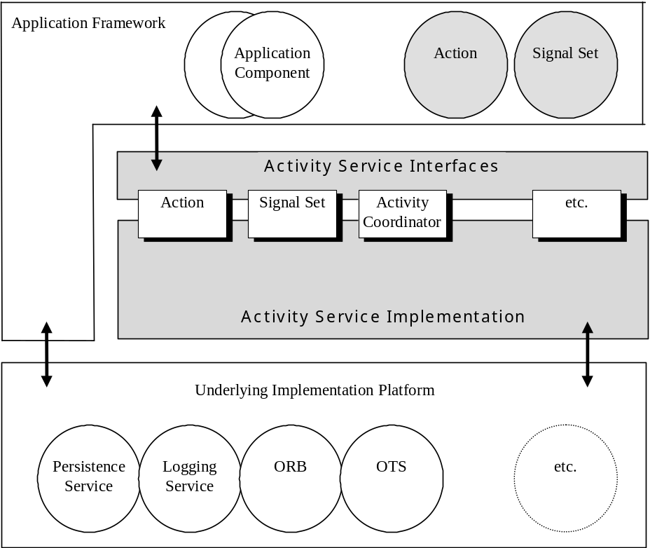
Figure 1, The role of the Activity Service.

Activity Service Interfaces and Implementation
The behaviour required of an Activity Service Implementation which offers the operations in the Activity Service Interfaces is the subject matter of this document. However, it will be useful to understand what an Activity Service Implementation is not expected to do by describing the responsibilities and expected behaviour of the applications that require it.

Application Framework
It is not expected that the operations in the Activity Services interfaces will be used directly by end-user application programmers. When we talk about application programmers in this document it is really those who write for example, workflow managers or component management systems or who are extending the functionality of the Containers of Enterprise Java Beans (EJBs). Extended transactions like the Sagas and Compensations described below have a complex structure and are intended to last over quite long intervals. Therefore a significant amount of middleware is required to manage the progress and recovery of an extended transaction and is not in the domain of an application programmer who is being employed to write business software rather than middleware.
In this document we have used the term Application Framework to describe the middleware required and to distinguish it from the business application logic of an Activity Component.
It is not the purpose of this document to propose the precise behaviour of such workflow management or component management systems -- indeed the OMG has already adopted two related specifications -- rather the purpose is to propose an Activity Service that is needed to allow such Application Frameworks to manage complex business transactions that will extend the concept of transaction from the well-understood, short-duration atomic transaction of the OMG’s Object Transaction service (OTS).
There are expected to be several Application Service Implementations that interoperate in the manner of this proposal and thus will allow extended transactions to span a network of transaction systems connected indirectly by an ORB.
It is one of the responsibilities of an Application Framework implementation to manage the persistent state of its applications; as opposed to the Application Service Implementation’s responsibility to manage the persistent state of its Activity Coordinators and other public and private objects.

Application Component
If the Application Framework is that middleware supplied by specialist vendors required to manage the progress of workflows and long-running business transactions in a variety of business domains, then the term Application Component describes the components that “plug in” to such a framework. The Workflow Management Coalition (WfMC) and the OMG’s Workflow Management Facility use the term Activity to describe a step in a path through a workflow digraph. An Application Component -- if it is to be reusable -- has to maintain a degree of independence from the Application Framework in which it runs. Thus a workflow manager might associate one or more Activities with a single Application Component each time giving it different properties that will serve to parameterize the enactment of the workflow [8]. For example, an Application Component that holds a conversation with a graphical user interface (GUI) may be associated with two Activities, one of which has a property “the end-user language is French”, the other which has “the end-user language is English”, or again, the Application Component could be composed into a larger Activity that must run as a business transactions whose effects can be undone in some situations, whereas it could also be composed into another, or used stand-alone where no transactional behaviour is involved at all.

Actions and Signal Sets
This is a proposal for an Activity Service that is sufficiently general in its behaviour to support a large variety of extended transaction types. As middleware vendors and their customers gain experience in developing and using extended transactions, so more types of extended transactions will emerge.
One of the keys to such extensibility is the Signal Set interface (described in detail below) whose implemented behaviour is peculiar to the kind of extended transaction. Similarly, the behaviour of an Action will be peculiar to the Application Framework of which it is a part. So as new types of extended transaction emerge, so will new Signal Set instances and associated Actions.
This allows a single Activity Service Implementation to serve a large variety of Application Frameworks, each with its own idea of extended transactions, each with its own Action and Signal Set implementations.
An Activity Service Implementation will not need to know what behaviour is encapsulated in the Actions and SignalSets it is given, merely interacting with their opaque interfaces in an entirely uniform and transparent way.

Underlying Implementation Platform
Different Activity Service Implementations will choose to use different combinations of the operating system and transaction services available to them. Although all implementations rely upon the existence of an ORB and an OTS, some implementations will have available to them a transaction system Logging Service and will choose to use it in preference to an Object Persistence Service in order to meet its obligation to recover the state of Activities that persist through failure and restart.
Any dependencies on the functionality of the ORB or Object Services are described below.

Activity Service Model

Overview
As shown in the diagram below, an application activity (shown by the dotted ellipse) is to be split into many different, coordinated, short-duration top-level transactions, to form a “logical long-running transaction”:
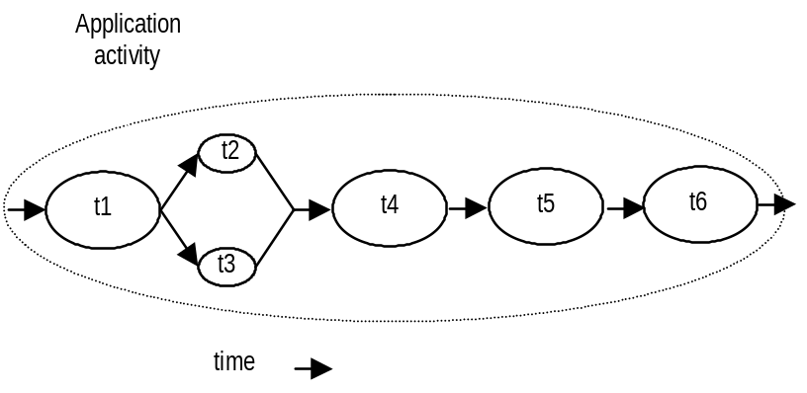
Figure 2, An example of a logical long-running “transaction”, without failure.
Let us assume that the application activity is concerned with booking a taxi (t1), reserving a table at a restaurant (t2), reserving a seat at the theatre (t3), and then booking a room at a hotel (t4).
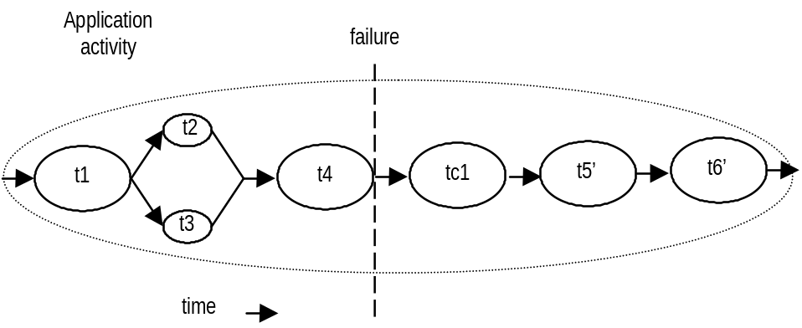
Figure 3, An example of a logical long-running “transaction”, with failure.
The reason for structuring the application activity as a “logical long-running transaction” rather than as a single top-level transactions is to prevent certain acquired resources from being held for the entire duration of the application. It is assumed that the application’s implementers have segmented the transactional activities within the application into smaller transactions, each such transaction being responsible for acquiring (and releasing) only those resources it requires.
However, if failures and concurrent access occur during the lifetime of these transactional activities then the behaviour of the entire “logical long-running transaction” may not possess ACID properties. Therefore, some form of (application specific) compensation may be required to attempt to return the state of the system to (application specific) consistency. For example, consider the above diagrams and let us assume that t4 has failed (rolls back). Further assume that the application can continue to make forward progress, but in order to do so must now undo some state changes made prior to the start of t4 (by t1, t2 or t3); since t4 is a transaction, its state changes will be undone automatically by the transaction system, so no form of compensation is required. Therefore, new activities are started; tc1 which is a compensation activity that will attempt to undo state changes performed, by say t2, and t3 which will continue the application once tc1 has completed. tc5’ and tc6’ are new activities that continue after compensation, e.g., since it was not possible to reserve the theatre, restaurant and hotel, it is decided to book tickets at the cinema. Obviously other forms of transaction composition are possible, e.g., t5’ could execute in parallel to tc1.
Much research on structuring applications out of transactions has been influenced by the ideas of spheres of control [7]. There are several ways in which some or all of the application requirements outlined above could be met. However, it is unrealistic to believe that the “one-size fits all” paradigm will suffice, i.e., a single high-level model approach to extended transactions is unlikely to be sufficient for all (or even the majority of) applications. Therefore, we propose a low-level infrastructure to support the coordination and control of abstract, application specific entities. As we shall show, these entities (activities) may be transactional, they may use weaker forms of serializability, or they may not be transactional at all; the important point is that we are only concerned with their control and coordination, leaving the semantics of such activities to the application programmer.
As we shall show, this distributed coordinator tree will support OTS strict two-phase commit transactions, nested transactions, as well as a variety of different kinds of “transactional behaviour” including long-running transactions similar to Sagas with Compensation, Flexible Transactions and Versioning Schemes. Any activity can be associated with issuing demarcation signals, e.g., the end of the saga, the beginning of a compensation group. These signals (or a subset of them) are communicated to any entities that have chosen to register for involvement in the activity context.
An activity is a unit of (distributed) work that may, or may not be transactional. During its lifetime an activity may have transactional and non-transactional periods. Every entity including other Activities can be parts of an Activity, although an activity need not be composed of other activities. An Activity is used to carry transactional and other essential specifications of the application’s contract with its middleware.
Each activity is represented by an activity object. An Activity is created, made to run, and then completed. The result of a completed activity is its outcome, which can be used to determine subsequent flow of control to other activities. Activities can run over long periods of time and can thus be suspended and then resumed later.
Demarcation signals of any kind are communicated to any registered entities (actions) through signals. For example, the termination of one activity may initiate the start/restart of other activities in a workflow-like environment. Signals can be used to infer a flow of control during the execution of an application. Actions allow an Activity to be independent of to the specific work it is required to do for signals.
This specification will describe basic interfaces that can be used to construct extended transaction models such as long running transactions. These may be used by, for example, workflow engines and applications to do compensation, activity demarcation etc. by sending specific signal information through the Action/Activity structure constructed through the proposed interfaces.
Activities and transactions
Note, in the rest of this document when we talk about “transactional activities” we simply mean activities that use (are using, or have used) transactions.
An activity may run for an arbitrary length of time, and may use transactions (and subtransactions) supplied by the Object Transaction Service implementations at arbitrary points during its lifetime. For example, consider Figure 4, which shows a series of connected activities co-operating during the lifetime of an application. The solid ellipses represent transaction boundaries, whereas the dotted ellipses are activity boundaries. Activity A1 uses two top-level transactions during its execution, whereas A2 uses none. Additionally, transactional activity A3 has another transactional activity, A3’ nested within it.
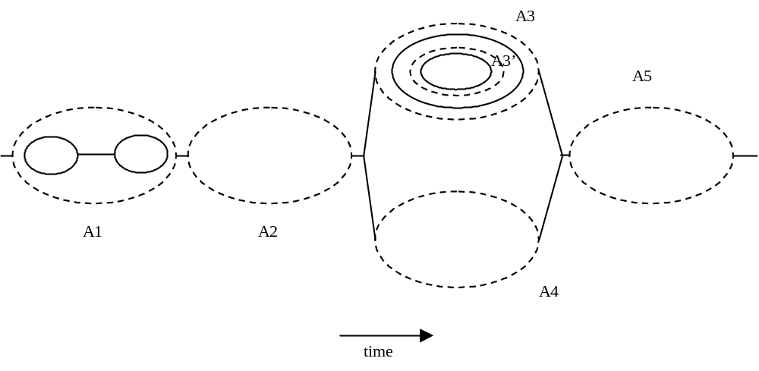
Figure 4, Activity and transaction relationship.
Just as a thread of control may require transactional and non-transactional periods and can suspend and resume its transactionality, so too may it require periods of non-activity related work. Thus, it is possible for an activity thread to perform some work outside the scope of the activity before returning to activity related work. In the example diagram above, if the thread performing activity A3’ decided to perform some non-activity related work, it could do so outside the scope of A3’ and A3. It is not possible to suspend an activity without suspending all of its enclosed transactions. It is desirable that suspending a transaction which has enclosed activities will also suspend those activities. However, this would require that the transaction service has knowledge of activities, and would require a change to the Object Transaction Service, which is outside the scope of this specification. A possible implementation which does not require changes to the OTS is briefly described in Section 2.2.
To ensure application integrity, suspending and resuming of activities implicitly works in conjunction with any transactions that may also be in flight within the activities.
Activity Outcome
An activity, which contains component activities, may impose a requirement on the Activity Service implementation for managing these component activities. It must be determined whether the nested Activities worked as specified or failed and how to map their completion (or non-completion) to the enclosing Activity’s outcome. This is true whether the nested Activities are strictly parallel, strictly sequential or a complex structure. In general, an Activity (or some entity acting on its behalf) that needs to co-ordinate the outcomes of component Activities has to know what state each component activity is in:
- which are active
- which have completed and what their outcomes were
- which activities failed to complete
This knowledge needs to be related to its own eventual outcome. A responsible entity may be required to handle the sub-activity outcomes; this specification does not mandate how this occurs, but it could be modeled as another Activity so that control flows can be made explicit. The activity determines the collective outcome of the component activity in the light of the various failure and success situations its component activities present it with.
It is outside the scope of this specification to provide interfaces for the outcome manager or to describe how such an entity should be constructed. In the case of complex activity applications, suitable scripting languages may be required to assist the application programmer to define the roles of outcome manager and activities.
Activity Failures
The failure of an individual Activity may produce application specific inconsistencies depending upon the type of activity, and how the application depends upon it.
- if the Activity was involved within a transaction, then any state changes it may have been making when the failure occurred will eventually be recovered by the transaction service implementation.
- if the Activity was not involved within a transaction, then application specific compensation may be required.
- an application that consisted of the (possibly parallel) execution of many activities (transactional or not) may still require some form of compensation to “recover” committed state changes made by prior activities. For example, the application shown in Figure 2.
This proposal considers that the compensation of the state changes made by an activity is simply the role of another activity; we do not distinguish between compensating and non-compensating activities. A compensating activity is simply performing further work on behalf of the application. Just as application programmers are expected to write “normal” activities, they will therefore also be required to write “compensating” activities, if such are needed. In general, it is only application programmers who possess sufficient information about the role of data within the application and how it has been manipulated over time to be able to compensate for the failure of activities. Automatic compensation of activities may be provided by systems and tools which use the activity framework presented in this proposal.
Activity Integrity
Activity service implementations must impose constraints on the use of activity interfaces to guarantee integrity. This is similar to the checked transaction behaviour of the Object Transaction Service, and an implementation may use similar algorithms to those presented within that specification. Implementations must ensure that all computations acting on behalf of the activity have completed prior to its termination to prevent loss of application integrity. Any enclosed transactions will be responsible for their own integrity checks; hence an Activity Service implementation need only be concerned with imposing checking constraints on work conducted outside the scope of transactions.
Signals, SignalSets and Actions
Activities interact with each other and the rest of the distributed system through Signals and Actions. An Activity may decide to transmit activity specific data (Signals) to any number of other Activities at specific times during its lifetime, e.g., when it terminates; each signal may be used to represent the requested outcome of the Activity. The receiving Activities may either have been running and are waiting for a specific Signal, or may started by the receipt of the Signals.
To allow Activities to be independent of the other activities, and also to allow the insertion of coordination and control points within an application which are outside of the domain of an Activity, Signals are sent to Actions, rather than Activities. (The role of an Action is similar that of the CosTransactions::Resource in the OTS.) An Action may then use the information encoded within the Signal in an application specific manner. When the Action has finished it may return an application specific indication of the outcome of its having dealt with the Signal. An Action may be considered as an entry/exit point into/from an Activity. However, this proposal does not restrict the role of the Action and this should be considered as an example of usage only.
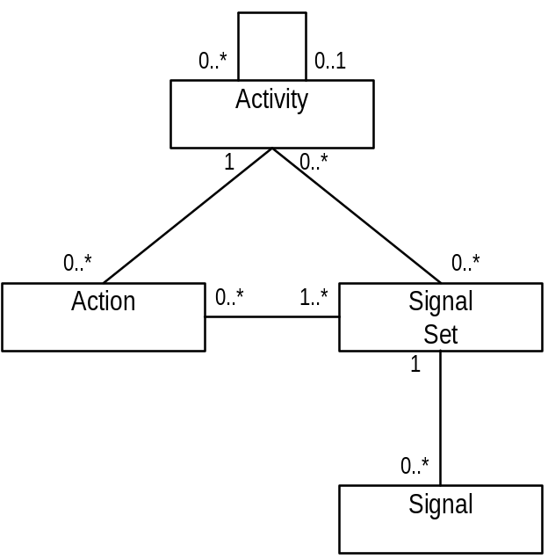
Figure 5, Relationship of SignalSets, Signals, Actions and Activities.
An activity coordinator may be implicitly associated with each activity, and is used to drive the Signal and Action interactions: if an Activity has no associated Actions, then it need not have an activity coordinator. Activities that require to be informed when another Activity sends a specific Signal can register an appropriate Action with that Activity’s coordinator. When the Activity sends a signal (e.g., at termination time), the coordinator’s role is to forward this signal to all registered Actions and to deal with the outcomes generated by the
Actions by passing them to the SignalSet; it is the SignalSet’s responsibility to collate many individual outcomes into a single outcome for the Activity.
To allow Actions to be selectively signaled, Signals are associated with SignalSets, and Actions are implicitly associated with SignalSets. When a Signal is raised it does so within the context of a specific SignalSet, and only those Actions registered with that SignalSet will receive the Signal. An Action may register interest in more than one SignalSet and an Activity may use more than one SignalSet during its lifetime.
With the exception of some predefined Signals and SignalSets, the majority of Signals and SignalSets will be defined and provided by the higher-level applications that make use of this Activity Service framework. To use the generic framework provided within this specification it is necessary for these higher-level applications to impose application specific meanings upon Signals and SignalSets, i.e., to impose a structure on their abstract form. A Signal with the name “foobar” can mean one thing when used within one application, but the same name may have a completely different meaning when used elsewhere.
A SignalSet is responsible for determining which Signals should be sent to registered Actions. The set of Signals a given SignalSet can generate may change from one use to another, and the actual set of Signals it sends may be a subset of these Signals. The intelligence about which Signal to send to an Action is hidden within a SignalSet and may be as complex or as simple as is required by the activity implementation. When a Signal is sent to an Action, the SignalSet is informed of the Outcome generated by that Action to receiving and acting upon that Signal; the SignalSet may then use that information when determining the nature of the next Signal to send. When a given Signal has been sent to all registered Actions the SignalSet will be asked for the next Signal to send by the Activity Coordinator. It is possible for the outcome of an Action to cause the premature fetching of a new Signal from a SignalSet such that not every registered Action will see all of the Signals the SignalSet produced.
When all Signals have been generated by the SignalSet, the Activity’s final Outcome can be obtained from the SignalSet. Since each individual Outcome returned from each Action (including failure Outcomes) have been passed to the SignalSet, it has the responsibility for determining the final Outcome for the Activity. Only the SignalSet has the necessary semantic information to interpret each Outcome in order to make this determination.
As shown below, a given SignalSet is assumed to implement a state machine, whereby it starts off in the Waiting state until it is required by the Activity Coordinator to send its first Signal, when it then either enters the Get Signal state or the End state if it has no Signals to send. Once in the End state the SignalSet cannot provide any further Signals and will not be reused. Once in the Get Signal state the SignalSet will be asked for a new Signal until it enters the End state. A new Signal is only requested from the SignalSet when all registered Actions have been sent the current Signal, or an exceptional outcome is generated by an Action.
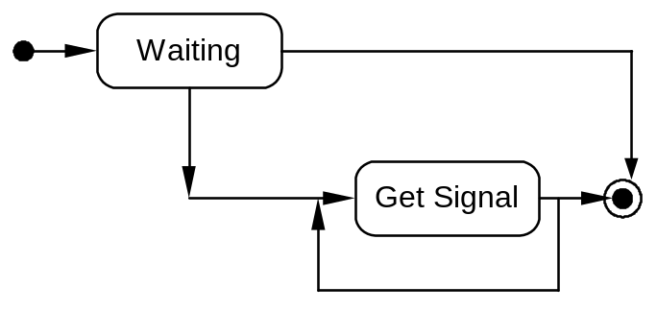
Figure 6, SignalSet state transition diagram.
For example, suppose we have two SignalSets to represent the possible outcomes for a transaction, Rollback and Commit, and register Actions with the Activity as the transactional resources; as with the OTS, it is up to the users of the Activity Service to ensure that appropriate Actions are registered at appropriate times.
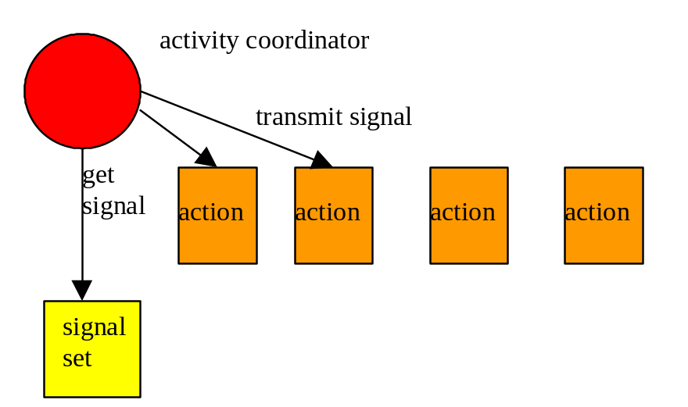
Figure 7, Activity coordinator signaling actions.
The Signal associated with the Rollback SignalSet would simply be “rollback”, whereas the Commit SignalSet would have “prepare”, “commit”, and “rollback” Signals. If the application decides to commit, then when called by the Activity Coordinator the SignalSet would generate the “prepare” Signal to be sent to the registered Actions, as shown in Figure 7. The Activity Coordinator would then send this Signal to each Action, and inform the SignalSet of the result. Assuming none of the Actions returns an exceptional response to this Signal, then when all Actions have received the “prepare” Signal, and the Activity Coordinator asks the SignalSet for the next Signal, it will return the “commit” Signal. However, if during the “prepare” phase, an Action returns a response which indicates that there is no point in sending the “prepare” Signal to further Actions, the Activity Coordinator will be required to obtain a new Signal from the SignalSet (the “rollback” Signal in this case), and send this to all registered Actions. As stated previously, the intelligence about which Signal to send, and about interpreting outcomes from Actions, resides within the SignalSet, allowing implementations of the framework presented within this specification to be highly configurable, to match application requirements.
The desired delivery semantics for Signals are at least once, although implementations are free to provide better deliver guarantees. This means that an Action may receive the same Signal from an Activity multiple times, and must ensure that such invocations are idempotent, i.e., that multiple invocations of the same Signal to an Action are the same as a single invocation.
Contexts
Whenever an entity within an Activity performs an operation it does so within that Activity’s context. Since Activities may be nested, the context may form a hierarchy. Because it is important that any operation executes within the correct context, whenever an entity invokes a remote operation on another entity it is necessary to transmit this context information between distributed entities.
Therefore, as part of the environment of each ORB-aware thread, the ORB maintains an activity context; if the activity is transactional then this activity context will have knowledge of the relevant transaction context. The activity context is either null (indicating that the thread has no associated activity) or it refers to a specific activity. It is permitted for multiple threads to be associated with the same activity at the same time, in the same execution environment or in multiple execution environments.
This specification implicitly assumes that transaction context information will be propagated implicitly between execution environments.
Although it is assumed that Portable Interceptor technology will be used to accomplish this, this is not mandated, and any similar mechanism may be used; a subsequent section will describe in detail the role required from an interceptor or its equivalent. However, it is assumed that for inter-operability purposes such mechanisms will work with implementations that do use Portable Interceptors. Additional POA attributes have been declared to provide a flexible way in which the activity context may flow between execution environment. These attributes will be described later in the proposal.
Properties
The programmer possesses application specific knowledge about how the application will use data, e.g., how locks on data should be obtained (optimistic pessimistic, for example), and how activities should deal with failures. An encompassed activity that needed to perform an update could override this. This configuration information may change during the lifetime of the application, as users requirements change. If such information were hard-wired into the application, each time a change to the configuration is made, the application would have to be rebuilt.
Therefore, what is required is a way to store this information as data, which can be modified without requiring changes to the applications and activities that use it. In addition, such data may be required to be shared between distributed activities. However, how this data is stored and accessed may also depend upon the application requirements. Therefore, rather than mandate a specific implementation for managing such properties, we simply provide a mechanism for applications to obtain their own “property store” implementations. This is the role of the PropertyGroup. A PropertyGroup represents properties as a tuple-space of attribute-value pairs.
A PropertyGroup may be associated with each (distributed) Activity. A PropertyGroup manages a group of properties and defines their behaviour with respect to:
- the visibility of changes made to properties in a nested Activity.
- the visibility of changes made to properties in “downstream” nodes.
- the manner in which property values are accessed in “downstream” nodes, i.e., whether properties are propagated by value or by reference.
An Activity can support any number of registered PropertyGroups, each with its own set of behaviour. In general it is desirable for all PropertyGroups to display the same behaviour with respect to nested Activities, although this is not required. That behaviour should be that, when a nested Activity is begun, all of the parent’s properties are still available and may be updated, but that updates are scoped to the Activity in whose scope they are made. Thus, when a nested Activity is completed, the parent PropertyGroup is restored to the state it had prior to the nested Activity starting.
Different PropertyGroup implementations may have different behaviours with respect to nested Activities. For example, one type of PropertyGroup may allow updated to properties to be transmitted within nested contexts, while another may not. There are obviously scenarios where both types of PropertyGroup could be used at the same time, e.g., PG1 could represent “client environment” information such as locale or codepage; overriding of this information within nested contexts would make no sense; PG2 may represent application context, certain parts of which may require to be available only for the specific context in which they were set.
Any number of named PropertyGroups may be registered with the Activity Service. When an Activity is begun, an instance of each registered PropertyGroup is created and initialised.
Note, an implementation of a PropertyGroup may use an implementation of the OMG’s Property Service specification.
Recovery
Recovering applications after failures, such as machine crashes or network partitions, is an inherently complex problem: the states of objects in use prior to the failure may be corrupt, and the references to objects held by remote clients may be invalid. At a minimum, restoring an application after a failure may require making object states consistent. The advantage of using transactions to control operations on persistent objects is that the transactions ensure the consistency of the objects, regardless of whether or not failures occur. A transaction system (e.g., one based upon the Object Transaction Service), will guarantee that in the event of failures, any transactions that were in flight will either be committed or rolled back, making permanent or undoing any changes to objects that had occurred, i.e., it will be as though the transactions either did not start, or completed as required.
Rather than mandate a particular means by which objects should make themselves persistent, many transaction systems simply state the requirements they place on such objects if they are to be made recoverable, and leave it up to the object implementers to determine the best strategy for their object’s persistence. The transaction system itself will have to make sufficient information persistent such that, in the event of a failure and subsequent recovery, it can tell these objects whether to commit any state changes or roll them back. However, it is typically not responsible for the application object’s persistence.
In a similar way, we do not want to mandate a specific persistence and recovery mechanism for the Activity Service. Rather we wish to state what the requirements are on such a service in the event of a failure, and leave it to individual implementers to determine their own recovery mechanisms. As far as end-users of the Activity Service and its applications are concerned, recovery is something that happens after a failure: how it happens is rarely of concern. In a distributed application, where an individual activity may run on different implementations of the Activity Service during its lifetime, recovery is the responsibility of these different implementations. Each implementation may perform recovery in a completely different manner, forming recovery domains. Therefore, we are more concerned with the requirements that the Activity Service places on recovery, rather than how such recovery occurs.
Unlike in a traditional transactional system, where crash recovery mechanisms are responsible for guaranteeing consistency of object data, the types of extended transaction applications we envision using this service will typically also require the ability to recover the activity structure that was present at the time of the failure. This will then enable the activity application to then progress onwards. However, it is not possible for the Activity Service to perform such complete recovery on its own; it will require the co-operation of the Transaction Service, the Activity Service and the application. Since it is the application logic that imposes meaning on Actions, Signals, and SignalSets in order to drive the activities to completion during normal (non-failure) execution, it is predominately this logic that is required to drive recovery and ensure activity components become consistent.
The recovery requirements imposed on the Activity Service and the applications that use it can be itemized as follows:
- application logic: the logic required to drive the activities during normal runtime will be required during recovery in order to drive any in-flight activities to application specific consistency. Since it is the application level that imposes meaning on Actions, Signals, and SignalSets, it is predominately the application that is responsible for driving recovery.
- rebinding of the activity structure: any references to objects within the activity structure which existed prior to the failure must be made valid after recovery.
- application object consistency: the states of all application objects must be returned to some form of application specific consistency after a failure.
- recover actions and signal sets: any Actions and SignalSets used to drive the activity application must be recovered.
If Activities and transactions co-operate within a given application, then the related recovery mechanisms will also be required to co-operate. Obviously it is not necessary for a user of the Activity Service implementation to use transactions at all, in which case only Activity recovery will be required in the event of a failure, i.e., it is possible to have recovery domains that do not require a transaction service implementation at all.

Coupling transactions and activities
It is possible for an Activity Service implementation to terminate (or mark for termination) both Activities and transactions because it has sufficient knowledge of both entities. However, without modifying the Object Transaction Service specification, the information about Activities executing within a transaction is not available to a terminating transaction; hence such a transaction cannot force the termination of any sub-activities, only sub-transactions.
It is important to enable the termination of a transaction to affect any enclosed Activities. This specification therefore requires that there be a uniform architectural model, whereby Activities and transactions can cause the termination of any enclosing Activities and transactions. Although some implementations of the Object Transaction Service may do this through proprietary extensions to their implementations, this is not strictly necessary. Activities may register a suitable CosTransactions::Resource to act on their behalf with any enclosing transaction upon creation; this Resource will be informed whenever the transaction terminates, and the Activity can then behave accordingly, e.g., force the transaction to rollback if the state of the Activity is not consistent.

Activity Service Modules

Overview
The CosActivity module provides a set of CORBA services which support the Activity Service Model presented earlier.
module CosActivity
{
exception NoActivity {};
exception ActivityPending {};
exception InvalidToken {};
exception InvalidState {};
exception ActionError {};
exception AlreadyDestroyed {};
exception ActionNotFound {};
exception ChildContextPending {};
exception InvalidParentContext {};
exception SignalSetUnknown {};
exception SignalSetAlreadyRegistered {};
exception SignalSetActive {};
exception SignalSetInactive {};
exception TimeoutOutOfRange {};
exception PropertyGroupUnknown {};
exception InvalidContext {};
interface ActivityCoordinator;
// The following system exceptions are added to support the Activity
// service
// INVALID_ACTIVITY
// ACTIVITY_COMPLETED
// ACTIVITY_REQUIRED
typedef sequence<octet> GlobalId;
enum Status
{
StatusActive,
StatusCompleting,
StatusCompleted,
StatusNoActivity,
StatusUnknown
};
enum CompletionStatus
{
CompletionStatusSuccess,
CompletionStatusFail,
CompletionStatusFailOnly
};
struct Signal
{
string signal_name;
string signal_set_name;
any application_specific_data;
};
struct Outcome
{
string outcome_name;
any application_specific_data;
};
struct PropertyGroupIdentity
{
string property_group_name;
any context_data;
};
struct ActivityIdentity
{
unsigned long type;
long timeout;
ActivityCoordinator coord;
sequence <octet> ctxId;
sequence <PropertyGroupIdentity> pgCtx;
any activity_specific_data;
};
struct ActivityContext
{
sequence <ActivityIdentity> hierarchy;
any invocation_specific_data;
};
interface PropertyGroup
{
readonly attribute string property_group_name;
void completed();
void suspended();
void resumed();
void destroy() raises(AlreadyDestroyed);
};
interface SignalSet
{
readonly attribute string signal_set_name;
Signal get_signal (inout boolean lastSignal);
Outcome get_outcome () raises(SignalSetActive);
boolean set_response (in Outcome response, out boolean nextSignal)
raises (SignalSetInactive);
void set_completion_status (in CompletionStatus cs);
CompletionStatus get_completion_status ();
void destroy() raises(AlreadyDestroyed);
};
interface Action
{
Outcome process_signal(in Signal sig) raises(ActionError);
void destroy() raises(AlreadyDestroyed);
};
typedef sequence<Action> ActionSeq;
interface ActivityCoordinator
{
Outcome complete_activity(in string signal_set_name)
raises(ActivityPending, ChildContextPending, SignalSetUnknown);
Outcome process_signal_set(in string signal_set_name)
raises(SignalSetUnknown);
Outcome get_completion_outcome ();
void add_signal_set (in SignalSet signal_set)
raises(SignalSetAlreadyRegistered);
void remove_signal_set (in string signal_set_name)
raises(SignalSetUnknown);
void add_action(in Action act, in string signal_set_name,
in long priority) raises(SignalSetUnknown);
void remove_action(in Action act) raises(ActionNotFound);
void add_actions(in ActionSeq acts, in string signal_set_name,
in long priority) raises(SignalSetUnknown);
ActionSeq remove_actions(in ActionSeq acts);
void add_global_action(in Action act, in long priority);
void remove_global_action(in Action act) raises(ActionNotFound);
long get_number_registered_actions(in string signal_set_name)
raises(SignalSetUnknown);
ActionSeq get_actions(in string signal_set_name) raises(SignalSetUnknown);
ActivityCoordinator get_parent_coordinator ();
GlobalId get_global_id ();
Status get_status ();
Status get_parent_status ();
string get_activity_name ();
boolean is_same_activity (in ActivityCoordinator ac);
unsigned long hash_activity ();
void destroy() raises(AlreadyDestroyed);
};
interface ActivityToken
{
ActivityContext get_context ();
void destroy() raises(AlreadyDestroyed);
};
interface Current : CORBA::Current
{
void begin(in long timeout) raises(InvalidState, TimeoutOutOfRange);
Outcome complete() raises (NoActivity,
ActivityPending, ChildContextPending);
Outcome complete_with_status(in CompletionStatus cs)
raises (NoActivity, ActivityPending, ChildContextPending,
InvalidState);
void set_completion_status (in CompletionStatus cs)
raises (NoActivity, InvalidState);
CompletionStatus get_completion_status () raises(NoActivity);
void set_completion_signal_set (in string signal_set_name)
raises (NoActivity, SignalSetUnknown, InvalidState);
string get_completion_signal_set () raises(NoActivity);
ActivityToken suspend();
void resume(in ActivityToken at)
raises (InvalidToken, InvalidParentContext);
ActivityToken suspend_all();
void resume_all(in ActivityToken at)
raises (InvalidToken, InvalidParentContext);
GlobalId get_global_id ();
Status get_status();
string get_activity_name ();
void set_timeout (in long seconds) raises(TimeoutOutOfRange);
long get_timeout ();
ActivityContext get_context();
void recreate_context(in ActivityContext ctx) raises(InvalidContext);
ActivityCoordinator get_coordinator();
ActivityCoordinator get_parent_coordinator();
ActivityIdentity get_identity ();
ActivityToken get_token ();
PropertyGroup get_property_group(in string name)
raises(PropertyGroupUnknown, NoActivity);
};
};
module CosActivityAdministration
{
exception PropertyGroupAlreadyRegistered {};
exception PropertyGroupNotRegistered {};
exception AttributeAlreadyExists {};
exception NoSuchAttribute {};
interface PropertyGroupAttributes
{
string get_attribute (in string name)
raises(NoSuchAttribute);
void set_attribute (in string name, in string value)
raises(AttributeAlreadyExists);
void replace_attribute(in string name, in string value);
};
interface PropertyGroupManager
{
CosActivity::PropertyGroup create(in CosActivity::PropertyGroup parent,
in CosActivity::GlobalId gid);
CosActivity::PropertyGroupIdentity marshal_request
(in CosActivity::PropertyGroup pg);
CosActivity::PropertyGroupIdentity marshal_response
(in CosActivity::PropertyGroup pg);
CosActivity::PropertyGroup unmarshal_request
(in CosActivity::PropertyGroupIdentity mpg,
in CosActivity::PropertyGroup pg,
in CosActivity::PropertyGroup parent,
in CosActivity::GlobalId gid);
void unmarshal_response(in CosActivity::PropertyGroupIdentity mpg,
in CosActivity::PropertyGroup pg);
void destroy() raises(CosActivity::AlreadyDestroyed);
};
interface Current : CosActivity::Current
{
void register_property_group(in string property_group_name,
in PropertyGroupManager manager,
in PropertyGroupAttributes attributes)
raises(PropertyGroupAlreadyRegistered);
void unregister_property_group(in string property_group_name)
raises(PropertyGroupNotRegistered);
};
};
module CosActivityCoordination
{
interface Current : CosActivityAdministration::Current
{
CosActivity::Outcome broadcast(in string signal_set_name)
raises(CosActivity::SignalSetUnknown,
CosActivity::NoActivity);
void add_signal_set(in CosActivity::SignalSet signal_set)
raises(CosActivity::SignalSetAlreadyRegistered,
CosActivity::NoActivity);
void remove_signal_set (in string signal_set_name)
raises(CosActivity::SignalSetUnknown, CosActivity::NoActivity);
void add_action(in CosActivity::Action act, in string signal_set_name,
in long priority) raises(CosActivity::SignalSetUnknown,
CosActivity::NoActivity);
void remove_action(in CosActivity::Action act)
raises(CosActivity::ActionNotFound, CosActivity::NoActivity);
void add_actions(in CosActivity::ActionSeq acts,
in string signal_set_name, in long priority)
raises(CosActivity::SignalSetUnknown, CosActivity::NoActivity);
CosActivity::ActionSeq remove_actions(in CosActivity::ActionSeq acts)
raises(CosActivity::NoActivity);
void add_global_action(in CosActivity::Action act, in long priority)
raises(CosActivity::NoActivity);
void remove_global_action(in CosActivity::Action act)
raises(CosActivity::ActionNotFound, CosActivity::NoActivity);
long get_number_registered_actions(in string signal_set_name)
raises(CosActivity::SignalSetUnknown, CosActivity::NoActivity);
CosActivity::ActionSeq get_actions(in string signal_set_name)
raises(CosActivity::SignalSetUnknown,
CosActivity::NoActivity);
};
};

Exceptions
The CosActivity and CosActivityAdministration modules define the following exceptions that can be raised by an operation.
exception NoActivity {};
exception ActivityPending {};
exception InvalidToken {};
exception AttributeAlreadyExists {};
exception NoSuchAttribute {};
exception ActionError {};
exception AlreadyDestroyed {};
exception ActionNotFound {};
exception SignalSetUnknown {};
exception SignalSetAlreadyRegistered {};
exception SignalSetActive {};
exception SignalSetInactive {};
exception PropertyGroupUnknown {};
exception PropertyGroupAlreadyRegistered {};
exception PropertyGroupNotRegistered {};
exception ChildContextPending {};
exception InvalidState {};
exception InvalidParentContext {};
exception TimeoutOutOfRange {};
exception InvalidContext {};

NoActivity Exception
The NoActivity exception is raised by methods on the Current interface where an Activity is required to be active on the thread but none is.

ActivityPending Exception
The ActivityPending exception is raised if an attempt is made to complete the Activity when it is active on a thread other than the calling thread.

InvalidToken Exception
The InvalidToken exception is raised by Current::resume if the specified ActivityContext is not valid or is nil.

AttributeAlreadyExists Exception
The AttributeAlreadyExists exception is raised by PropertyGroupAttributes::set_attribute if the specified attribute is already set.

NoSuchAttribute Exception
The NoSuchAttribute exception is raised by PropertyGroupAttributes::get_attribute if the specified attribute does not exist.

ActionError Exception
The ActionError exception is raised by the Action during signal processing if it encounters an error it cannot handle.

AlreadyDestroyed Exception
The AlreadyDestroyed exception is raised by an interface if there are multiple attempts to destroy it.

ActionNotFound Exception
The ActionNotFound exception is raised by the ActivityCoordinator if an attempt is made to remove an Action it has no information about.

SignalSetUnknown Exception
The SignalSetUnknown exception is raised by the ActivityCoordinator if it is instructed to use a specified SignalSet it does not know about.

SignalSetAlreadyRegistered Exception
The SignalSetAlreadyRegistered exception is raised by the ActivityCoordinator if multiple attempts to register a SignalSet are made.

SignalSetActive Exception
The SignalSetActive exception is raised by the SignalSet when an attempt is made to obtain its final status before the SignalSet has completed producing Signals.

SignalSetInactive Exception
The SignalSetInactive exception is raised by the SignalSet if an attempt is made to use the SignalSet without having first called get_signal.

PropertyGroupUnknown Exception
The PropertyGroupUnknown exception is raised if an attempt it made to obtain an unknown PropertyGroup.

PropertyGroupAlreadyRegistered Exception
The PropertyGroupAlreadyRegistered exception is raised if multiple attempts to register a PropertyGroup are made.

PropertyGroupNotRegistered Exception
The PropertyGroupNotRegistered exception is raised if an attempt is made to unregister a PropertyGroup that has not previously been registered.

ChildContextPending Exception
The ChildContextPending exception is raised if an attempt is made to successfully complete an Activity when it still has active child Activities.

InvalidState Exception
The InvalidState exception is raised to indicate that the completion status of the Activity is incompatible with the attempted invocation.

InvalidParentContext Exception
The InvalidParentContext exception is raised either if an attempt is made to resume a suspended context within a different hierarchy than that which it was originally suspended from, or an attempt is made to call CosActivity::suspend on an Activity that is nested within a transaction.

TimeoutOutOfRange Exception
The TimeoutOutOfRange exception is raised if an attempt it made to associated an invalid timeout with a newly created Activity.

InvalidContext Exception
The InvalidContext exception is raised to indicate that a context could not be correctly imported.

INVALID_ACTIVITY Exception
The INVALID_ACTIVITY system exception may be raised on the Activity or Transaction services’ resume methods if a transaction or Activity is resumed in a context different to that from which it was suspended. It is also raised when an attempted invocation is made that is incompatible with the Activity’s current state.

ACTIVITY_COMPLETED Exception
The ACTIVITY_COMPLETED system exception may be raised on any method for which Activity context is accessed. It indicates that the Activity context in which the method call was made has been completed due to a timeout of either the Activity itself or a transaction that encompasses the Activity, or that the Activity completed in a manner other than that originally requested.

ACTIVITY_REQUIRED Exception
The ACTIVITY_REQUIRED system exception may be raised on any method for which an Activity context is required. It indicates that an Activity context was necessary to perform the invoked operation, but one was not found associated with the calling thread.

typedefs

GlobalId
This sequence of octets is used to uniquely identify the Activity. It is implementation dependant as to the information that may be contained within GlobalId.

Enumerations

Status
During the existence of the activity its status will either be running, completing, or completed:
enum Status
{
StatusActive,
StatusCompleting,
StatusCompleted,
StatusNoActivity,
StatusUnknown
};
The meaning of each of the above values is given below:
- StatusActive: An Activity is associated with the target object and the Activity is in the active state. An implementation returns this status after an Activity has been started and prior to its beginning completion.
- StatusCompleting: An Activity is associated with the target object and it is in the process of completing. An implementation returns this status if it has started to complete, but has not yet finished the process. This value indicates that the activity may be performing activity specific work required to determine its final completion status. An activity must enter this state prior to completion, even if this state does nothing.
- StatusCompleted: An Activity is associated with the target object and it has completed. The actual outcome of the completed Activity will depend upon the type of Activity, e.g., a transactional Activity may complete in a Committed, or RolledBack state. Obtaining such states will be application specific.
- StatusNoActivity: No Activity is currently associated with the target object. This will occur after an Activity has completed, or before the first Activity is created.
- StatusUnknown: An Activity is associated with the target object, but the Activity Service cannot determine its current status. This is a transient condition, and a subsequent invocation will ultimately return a different status.
The diagram below indicates the transitions that an Activity can undergo.
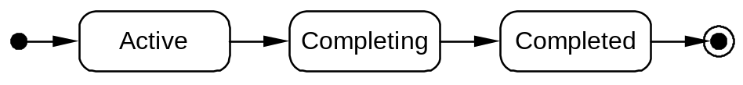
Figure 8, Activity UML state diagram

CompletionStatus
enum CompletionStatus
{
CompletionStatusSuccess;
CompletionStatusFail;
CompletionStatusFailOnly;
};
When an Activity completes, it does so in one of two states, either success or failure. During its lifetime, the completion state of the Activity (i.e., the state it would have if it completed at that point) may change from success to failure, and back again many times. This is represented by the CompletionStatus enumeration, whose values are:
- CompletionStatusSuccess: the Activity has successfully performed its work and can complete accordingly. When in this state, the Activity completion status can be changed.
- CompletionStatusFail: some (application specific) error has occurred which has meant that the Activity has not performed all of its work, and should be driven during completion accordingly. When in this state, the Activity completion status can be changed.
- CompletionStatusFailOnly: some (application specific) error has occurred which has meant that the Activity has not performed all of its work, and should be driven during completion accordingly. Once in this state, the completion status of the Activity cannot be changed, i.e., the only possible outcome for the Activity is for it to fail.
The interpretation of the completion status outcome to drive specific Signals and Activity specific work is up to the actual Activity.

Structures

Signal
struct Signal
{
string signal_name;
string signal_set_name;
any application_specific_data;
};
An Activity may enable Signal objects to be transmitted to entities to inform them about activity specific events. Activity specific information (e.g., about how the Activity terminated) is encoded within the Signal.
signal_name is an identifier for the Signal, and can be used to determine the meaning of the Signal. It is invalid for this field to be nil. This name must be unique within the context of the SignalSet.
signal_set_name is the name of the SignalSet this Signal is associated with. It is invalid for this field to be nil. These names must be unique, and adhere to the following naming convention: <domain>.<company>.<…>; so, for example, “com.ibm.fred.otssignals”.
The application_specific_data field may be used to encode additional application specific information.
Predefined signal types include:
- preCompletion: the recipient is informed that the Activity is about to complete. This Signal will only be called if the Activity’s completion status is CompletionStatusSuccess. The Activity’s completion status is encoded within the Signal.
- postCompletion: the recipient is informed that the Activity has completed. Information about the Activity’s completion status, which may have changed since preCompletion, is encoded within the Signal.

- childBegin: the recipient is informed that the Activity has begun. The identity of the child (i.e., its GlobalId) is encoded within the Signal.
- childComplete: the recipient is informed that the Activity has completed. The identity of the child (i.e., its GlobalId) is encoded within the Signal.
An Activity Service implementation will not modify the application_specific_data field of any Signal.

Outcome
struct Outcome
{
string outcome_name;
any application_specific_data;
};
When an Action receives a specific Signal it returns an Outcome that represents the result of its having dealt with the Signal. When an Activity completes, an Outcome may be returned to the application in order for it to determine the final status of the Activity.
outcome_name is an identifier for the Outcome, and can be used to determine the meaning of the Outcome. It is invalid for this field to be nil.
The application_specific_data field may be used to encode additional application specific information.
Actions are required to use the ActionError exception to indicate that some failure occurred during Signal processing. This exception is mapped onto the pre-defined Outcome “ActionError”. Other system exceptions (such as the failure of an Action to respond to a given Signal), are mapped onto the pre-defined Outcome “ActionSystemException”, and information about the exception is encoded within the application_specific_data field.

ActivityIdentity and ActivityContext
struct ActivityIdentity
{
unsigned long type;
long timeout;
ActivityCoordinator coord;
sequence <octet> ctxId;
sequence <PropertyGroupIdentity> pgCtx;
any activity_specific_data;
};
struct ActivityContext
{
sequence <ActivityIdentity> hierarchy;
any invocation_specific_data;
};
Activities may be composed of other Activities. If an activity is started within the scope of an already running Activity, then it will automatically be nested within that Activity, i.e., it will be a child Activity. Thus, the execution of a series of Activities may form a hierarchy. When entities within an Activity invoke objects in other address spaces, information about the context in which these invocations are made must flow with the invocation.
Each activity may have an arbitrary number of transactions running within it (or none), and the top entities within such a hierarchy may be transactions. A receiving execution domain may be required to recreate the imported activity context such that recreated activities are running within the right (recreated) transaction scopes. Transaction context propagation issues are dealt with by the Object Transaction Service specification and will not be discussed here. However, sufficient information needs to be shipped by the exporting Activity Service to enable importing environments to recreate the sent Activity context, such that recreated Activities and transactions are nested in the importing environment in the same way they are in the exporting environment.
The objects using a particular Activity Service implementation in a system form an Activity Service domain. Within the domain, the structure and meaning of the activity context information can be private to the implementation. When leaving the domain, this information must be translated to a common form if it is to be understood by the target Activity Service domain. Therefore, an Activity context (hierarchy) is represented by the ActivityContext, which is an ordered sequence of ActivityIdentitys. The first element in the sequence represents the current Activity/transaction, and the last represents the root of the hierarchy.
The type field, which must be a positive, non-zero value, is used to indicate the type of the element for which the information is being maintained. Currently supported values are:
- 1: the element in the hierarchy is a transaction.
- 2: the element in the hierarchy is an Activity.
An element within the hierarchy is uniquely identified by an instance of ActivityIdentity. If the type field indicates that the element is an Activity, then the coord field will be set, and ctxId will be the Activity’s unique identifier. If the type field indicates that the element is a transaction, then the coord field will be nil, and the ctxId will be the tid portion of the CosTransactions::otid_t representation for the OTS transaction at this level in the hierarchy.
Although the ActivityIdentity contains a field for the tid portion of the transaction’s CosTransactions::otid_t, this is merely so that the position of any transaction context can be recorded relative to the Activity context (if any) within which it was started. Each nested transaction is represented by exactly one ActivityIdentity, which marks the sub-transaction’s position within the hierarchy.
In order to reduce the amount of context information which is transmitted between execution domains where nested transactions are used, the ActivityContext structure need only contain information on an activity’s most deeply nested transaction, since this is sufficient to be able to recreate the entire activity/transaction hierarchy.
The Activity Service uses the PropertyGroupManagers to fill in the pgCtx field.
The timeout field indicates the application specific timeout associated with the activity or transaction when it was created. (If this instance represents a subtransaction, then this field will be -1.) If the activity or transaction has not completed within this time period then it will be completed with CompletionStatusFail.
Additional information may be encoded within the
activity_specific_data and invocation_specific_data fields. It is legal for these fields to contain an empty any. An implementation must not rely on the data that was sent with an outbound context being available on the reply context. Because this information is likely to be specific to a given implementation of the Activity Service it is illegal for an importing domain that is different from the exporting domain to use these fields. To ensure integrity of the application (specifically in the case of loop-backs between foreign and native domains), a domain which does not understand the anys within an activity context must at least replace them all with empty anys. Such a domain is free, however, to replace the anys with implementations specific to itself, but only if it replaces them all.

Distributing Context Information
It is assumed that an appropriate Portable Interceptor will be used to deal with sending and receiving activity context information; this will require the interceptor to un/marshal the context from/into the correct position in the Service Context structure. If Portable Interceptors are not used, then similar mechanisms must be used in order to ensure that context information flows implicitly between execution environment. To ensure interoperability between Activity Service implementations, mechanisms which do not rely upon Portable Interceptors should behave in a similar way to an interceptor and encode the context information appropriately.
It is the responsibility of the Activity Service implementation to register a client and server side interceptor. This is achieved by calling:
- PortableInterceptor::ORBInitInfo::add_client_request_interceptor(in ClientRequestInterceptor)
- PortableInterceptor::ORBInitInfo::add_server_request_interceptor(in ServerRequestInterceptor)
The interceptor is responsible for marshalling/demarshalling any Activity context information at the appropriate interception points.
Policing the sending/receiving of Activity context information is dependant on the POA attributes described in the next section.

Activity Service POA Attributes
In order to control the flow of Activity context information, the following POA policy attributes are required that will be added to an object’s IOR profile by the server for the benefit of the client/server interceptor:
typedef unsigned short ActivityPolicyValue;
const ActivityPolicyValue IGNORES = 0; // This is the default
const ActivityPolicyValue SUPPORTS = 1;
const ActivityPolicyValue REQUIRES = 2;
const ActivityPolicyValue REQUIRES_NONE = 3;
const CORBA::PolicyType ActivityPolicyType = ??; // To be allocated by FTF
interface ActivityPolicy : CORBA::Policy
{
readonly attribute ActivityPolicyValue apv;
}

The semantics of these policies will now be described (in the following section the term apv is the ActivityPolicyValue in the Activity component of the target object IOR. Note that an apv of IGNORES should always be treated by a client in the same way as an IOR with no Activity component.
Client-side
- If apv is IGNORES, or if there is no ActivityPolicy, then a method request made within the scope of an Activity should be sent (which is an important distinction from OTS 1.2) but without the Activity context. This would include any requests to objects on a non-Activity aware ORB (IGNORES is the same as no ActivityPolicy).
- If apv is SUPPORTS then an Activity context must be sent if and only if an Activity context is associated with the thread of the caller.
- If apv is REQUIRES then a method request must be sent with an Activity context. If there is no Activity context then the client-side Activity service interceptor must raise the ACTIVITY_REQUIRED system exception and must not send the request.
- If apv is REQUIRES_NONE then no Activity context is allowed to be sent. If there is an Activity context active on the thread then the client-side Activity service interceptor must raise the INVALID_ACTIVITY system exception and must not send the request.
Server-side
The server-side Activity service interceptor should behave as follows when processing inbound requests:
- If apv is IGNORES, any Activity context must be ignored but the method invocation should not be prevented. Given the client-side behaviour above, the server should never have to deal with this situation. Given that this situation constitutes a client-side error, an implementation may throw a system exception if this happens. The need for an IGNORES policy at all is as a convenience for a client application so that the application itself does not have to suspend in order to invoke a method on an object that does not participate in an Activity.
- If apv is SUPPORTS then any received Activity context must be moved onto the thread of execution.
- If apv is REQUIRES then any received Activity context must be moved onto the thread of execution. If no Activity context is received the server-side Activty service interceptor must throw the ACTIVITY_REQUIRED system exception, thereby preventing the request from being dispatched.
- If apv is REQUIRES_NONE then the server-side Activity service interceptor is required to check that no Activity context has been flowed with the request and to throw the INVALID_ACTIVITY system exception if it has, thereby preventing the request from being dispatched.

Combinations of TransactionPolicyValues and ActivityPolicyValues

There are 8 TransactionPolicyValues and 4 ActivityPolicyValues leading to a total number of 32 possible combinations. This may be simplified by considering, from the Activity services’ point of view, redundancy between shared and unshared transactions. This reduces to 4 the number of distinct TransactionPolicyValues. The following table describes client-side behaviour when there are both transaction and Activity contexts on the client thread when a remote request is made and server-side behaviour when there are both transactions and Activity contexts received with an inbound request.
APV | TPV | Client-side behaviour | Server-side behaviour
IGNORES | IGNORES | If the TransactionalCallPolicyValue indicates ALLOW_NON_TRANSACTIONAL_CALLS then the method invocation succeeds, but no Activity context is sent. The transaction context may or may not be sent, but is ignored by the server. If the TransactionalCallPolicyValue indicates REQUIRES_TRANSACTIONAL_CALLS then the method invocation fails with TRANSACTION_MODE. | Any received Activity or transaction context is ignored.
IGNORES | REQUIRES_NONE | The method invocation fails with INVALID_TRANSACTION. | INVALID_TRANSACTION is thrown.
IGNORES | SUPPORTS or REQUIRES | The method invocation succeeds, but only the transaction context is sent. | The transaction context is associated with the thread. Any received Activity context is ignored.
SUPPORTS or REQUIRES | IGNORES | If the TransactionalCallPolicyValud indicates ALLOWS_NON_TRANSACTIONAL_CALLS then the method invocation succeeds and the Activity context is sent. The transaction context may or may not be sent but is ignores by the server. If the TransactionalCallPolicyValue indicates REQUIRES_TRANSACTIONAL_CALLS then the method invocation fails with TRANSACTION_MODE. | The Activity context is associated with the thread. Any received transaction context is ignored.
SUPPORTS or REQUIRES | REQUIRES_NONE | The method invocation fails with INVALID_TRANSACTION | INVALID_TRANSACTION is thrown.
SUPPORTS or REQUIRES | SUPPORTS or REQUIRES | The method invocation succeeds and both contexts are sent. | Both contexts are associated with the thread.
REQUIRES_NONE | REQUIRES_NONE | The method invocation fails with either INVALID_ACTIVITY or INVALID_TRANSACTION. The exact exception depends upon which interceptor is run first. | The method invocation fails with either INVALID_ACTIVITY or INVALID_TRANSACTION. The exact exception depends upon which interceptor is run first.
REQUIRES_NONE | IGNORES | The method invocation fails with either INVALID_ACTIVITY or TRANSACTION_MODE. The exact exception depends upon which interceptor is run first. | INVALID_ACTIVITY is thrown.
REQUIRES_NONE | REQUIRES or SUPPORTS | The method invocation fails with INVALID_ACTIVITY. | INVALID_ACTIVITY is thrown.
Table 1, Activity Service and OTS POA attributes and their interactions.

PropertyGroupIdentity
struct PropertyGroupIdentity
{
string property_group_name;
any context_data;
};
PropertyGroups form part of the Activity Service context. It is dependant upon the implementations of each PropertyGroup how information about them flows in the context. Therefore, it is up to the PropertyGroupManager to marshal and unmarshal PropertyGroups appropriately. The PropertyGroupIdentity structure is used to encapsulate this marshaled form of the PropertyGroup.
property_group_name is the name of the PropertyGroup. Implementations must ensure that such names are unique within the required domain.
context_data represents the marshaled form of the PropertyGroup.

Interfaces

SignalSet Interface
interface SignalSet
{
readonly attribute string signal_set_name;
Signal get_signal(inout boolean lastSignal);
boolean set_response(in Outcome response, out boolean nextSignal)
raises(SignalSetInactive);
Outcome get_outcome () raises(SignalSetActive);
void set_completion_status (in CompletionStatus cs);
CompletionStatus get_completion_status ();
void destroy() raises(AlreadyDestroyed);
};
The SignalSet is used to define the individual signals that are broadcast to the Action objects. Actions that have been registered as being interested in a specific SignalSet are sent Signals from that SignalSet. Typically once all Actions have received a given Signal, the SignalSet is asked for the next Signal to be sent to all of the Actions, if any.
If a SignalSet fails to produce Signals (e.g., it is physically remote from the ActivityCoordinator and fails to respond to invocations), then the completion status of the Activity is set to CompletionStatusFailOnly, and the ActivityCoordinator should act accordingly.
Once the Activity has begun to complete (the ActivityCoordinator has retrieved the first Signal from a SignalSet), the status of the Activity is under the control of the SignalSets, and cannot be changed directly by any other entity.

Signals are specified as members of SignalSets. As mentioned previously, it is envisioned that the majority of Signals and SignalSets will be defined by the higher-level extended transaction systems that use this Activity framework. Only such systems have the necessary application and activity specific knowledge to impose structure on the meaning of specific Signals and SignalSets. However, there are a small set of pre-defined signal sets and their associated signals, which are provided by implementations of the Activity Service:
- org.omg.ChildLifetime: childBegin, childComplete
- org.omg.Synchronization: preCompletion, postCompletion
These pre-defined SignalSets are implicitly associated with every Activity when it is created, and an application need not register them itself, i.e., no call to ActivityCoordinator::add_signal_set is required. Pre-defined SignalSets do not return any Outcome from get_outcome.
org.omg.ChildLifetime
The ChildLifetime SignalSet is invoked when a sub-Activity is begun, and when it completes. If an Action error occurs during childBegin (e.g., the ActionError exception is thrown) then the Activity completion status will be set to CompletionStatusFailOnly. There is no effect on the completed Activity if a failure occurs during childComplete.
The ChildLifetime Signal childComplete is sent after the Synchronization Signal postCompletion.
org.omg.Synchronization
The Synchronization SignalSet has a similar role to that of Synchronization objects within the OTS, i.e., it is invoked before and after completion of the Activity. Likewise, the completion status of an Activity may be changed by the Actions registered with this SignalSet, such that the Activity’s outcome when postCompletion is called may be different to that when preCompletion was invoked. If an Action error occurs during preCompletion (e.g., the ActionError exception is thrown) then the Activity completion status will be set to CompletionStatusFailOnly. There is no effect on the completed Activity if a failure occurs during postCompletion.
The preCompletion SignalSet is only sent if the Activity’s completion status is CompletionStatusSuccess. In the event of no crash failures that prevent the ActivityCoordinator from completing its work, postCompletion is sent regardless of the Activity’s completion status.
If there are any Actions registered with it, then the Synchronization SignalSet will be called prior using any application specific SignalSets. If an Action fails to respond to preCompletion or a failure occurs, then the completion status of the Activity is changed to CompletionStatusFailOnly. If the SignalSet decides that the next Signal (postCompletion) is required or normal processing of preCompletion has finished, then the implementation of the Activity Service must invoke the application specific SignalSet (if any) with the (potentially new) completion status obtained from get_completion_status of the Synchronization SignalSet, i.e., postCompletion is not called immediately. When the application SignalSet has finished producing Signals the postCompletion Signal should be sent to registered Actions. Errors during postCompletion have no effect on the outcome of the Activity.

set_completion_status
This method is used to provide the Activity’s completion status to the SignalSet during its generation of Signals, such that it can use the status to determine the sequence of Signals to produce.

get_completion_status
This returns the Activity’s completion status as the SignalSet has recorded it (and as it may have been modified during Signal processing). If the SignalSet has not generated any Signals (i.e., is inactive), then SignalSetInactive is thrown.
signal_set_name
Returns the name of this SignalSet. These names must be unique, and adhere to the following naming convention: <domain>.<company>.<…>; so, for example, “com.ibm.fred.otssignals”.
get_ signal
Returns the Signal to be sent to the Action objects registered for this signal set. If nil is returned, or the boolean output parameter lastSignal is true, then this indicates that no other signals are to be sent and the SignalSet will not be asked for further Signals. The Signal returned may depend upon the responses received from Actions that have been sent previous signals.
set_response
This method is called to notify the SignalSet of the response (the Outcome) from the Action object. The SignalSet returns a boolean to indicate whether or not the Action that returned the response should be informed of any further signals from this signal set; if the value is true then the Action continues to receive Signals. If nextSignal is true then no further work with the current Signal should be performed and the registered Actions should be sent the next Signal belonging to this SignalSet. For example, if an Action returns a failure condition on some Signal (say “prepare”), which indicates that it is pointless to send further signals of this type to other Actions, nextSignal would be set to true. The next signal obtained from get_signal may then be different from that which would have been obtained if no failure condition had been observed. If get_signal has not yet been called, then SignalSetInactive will be
thrown. It is valid for the Outcome parameter to be nil.
get_outcome
Returns the final outcome of the SignalSet; it is valid for this value to be nil. If the SignalSet has not finished producing Signals, then the SignalSetActive exception will be thrown. The Synchronization and ChildLifetime SignalSets return nil.
destroy
This method is invoked when the SignalSet is no longer required by the Activity service.

Action Interface
interface Action
{
Outcome process_signal(in Signal sig) raises(ActionError);
void destroy() raises(AlreadyDestroyed);
};
Instances of the Action interface may be registered with running Activities, such that when the Activities require Signal processing, the registered Actions will be invoked. When an Action is invoked, it is passed a Signal object that can be used to do application specific work.
An Action is implicitly associated with a single Activity and should be registered only once with that Activity. An Action may receive many different Signals and SignalSets.
process_signal
This method is invoked by the Activity service during signal processing. The Action returns an Outcome to indicate the outcome of the processing operation.
destroy
This method is invoked when the Action is no longer required by the Activity service, e.g., because the Activity it is registered with has completed.

ActivityToken Interface
interface ActivityToken
{
ActivityContext get_context ();
void destroy() raises(AlreadyDestroyed);
};
In order to allow for efficient implementations of inter- and intra- process Activity coordination and control, the Activity Service provides two different representations for the ActivityContext. When an Activity is suspended from an active thread, an ActivityToken is returned which is a handle to the activity context and is only valid within the obtaining execution domain. This can later be used to resume the Activity on the same, or other thread. The ActivityToken is implicitly associated with a single Activity, and thus the context it represents can be obtained from it. This is preferable to having to deal with the entire ActivityContext when suspending and resuming in a local environment.
get_context
Returns the ActivityContext represented by this ActivityToken. If the token was obtained by a call to CosActivity::suspend_all then the entire hierarchy context will be returned, otherwise only the current context.
destroy
This method is invoked when the ActivityToken is no longer required by the Activity service.

ActivityCoordinator Interface
interface ActivityCoordinator
{
Outcome complete_activity(in string signal_set_name)
raises(ActivityPending, ChildContextPending, SignalSetUnknown);
Outcome process_signal_set(in string signal_set_name)
raises(SignalSetUnknown);
Outcome get_completion_outcome ();
void add_signal_set (in SignalSet signal_set)
raises(SignalSetAlreadyRegistered);
void remove_signal_set (in string signal_set_name)
raises(SignalSetUnknown);
void add_action(in Action act, in string signal_set_name,
in long priority) raises(SignalSetUnknown);
void remove_action(in Action act) raises(ActionNotFound);
void add_actions(in ActionSeq acts, in string signal_set_name,
in long priority) raises(SignalSetUnknown);
ActionSeq remove_actions(in ActionSeq acts);
void add_global_action(in Action act, in long priority);
void remove_global_action(in Action act) raises(ActionNotFound);
long get_number_registered_actions(in string signal_set_name)
raises(SignalSetUnknown);
ActionSeq get_actions(in string signal_set_name) raises(SignalSetUnknown);
ActivityCoordinator get_parent_coordinator ();
GlobalId get_global_id ();
Status get_status ();
Status get_parent_status ();
string get_activity_name ();
boolean is_same_activity (in ActivityCoordinator ac);
unsigned long hash_activity ();
void destroy() raises(AlreadyDestroyed);
};
The ActivityCoordinator is responsible for coordinating the interactions between Activities through Signals, SignalSets and Actions, i.e., in the model presented earlier it “ties” up the Actions of Activities.
It is not strictly necessary for an implementation of the Activity Service to create an ActivityCoordinator prior to distributing a context between execution environments in which it was begun. Each Activity may be managed by at most one ActivityCoordinator.
Implementations of the Activity Service may use interposition to reduce the number of network messages required to complete an activity.
Once the ActivityCoordinator has used all of the Signals generated by the SignalSet, it may invoke the destroy operation on all registered Actions, including those that may have been registered with other SignalSets and hence not received Signals during Activity termination.
complete_activity
This instructs the ActivityCoordinator to complete the Activity using the specified SignalSet when sending signals to registered Actions. If the SignalSet is unknown the SignalSetUnknown exception will be raised; it is valid for the specified SignalSet to be null. If an Action throws the ActionError or System exception then it is dependant upon the SignalSet implementation as to whether the ActivityCoordinator stops sending signals to other registered Actions; this may depend upon the type of Signal that was being processed at the time the exception occurred. If the Action throws ActionError or any system exception then this may be mapped into either the pre-defined Outcomes “ActionError” or “ActionSystemException” respectively and passed to the SignalSet; for system exceptions, the exception is also passed in the application_specific_data portion of the Outcome. If the ActivityCoordinator is currently processing Signals when complete_activity is invoked, or has already completed, the INVALID_ACTIVITY exception is thrown. Successful completion of this method causes the Outcome, if any, of the SignalSet processing to be returned. It is valid for this return value to be nil. It is invalid to attempt to explicitly use the Synchronization or ChildLifetime SignalSets, and BAD_OPERATION will be thrown under these circumstances. The pre-defined SignalSets Synchronization and ChildLifetime will be automatically invoked during Activity completion if Actions have registered in them. If there are any encompassed active or suspended Activities or transactions, and the completion status is CompletionStatusSuccess, then ChildContextPending is raised. If the completion status is CompletionStatusFail or CompletionStatusFailOnly, any encompassed active or suspended Activities will have their completion status set to CompletionStatusFailOnly and transactions will be marked as rollback_only. If the thread from which the complete_activity call is made is not the only thread on which the Activity is active, then the ActivityPending exception is raised. It is recommended that this operation not be called directly.

process_signal_set
This instructs the ActivityCoordinator to use the specified SignalSet when sending signals to registered Actions; this method cannot be used to complete the Activity, and complete_activity should be used instead. If the SignalSet is unknown the SignalSetUnknown exception will be raised; it is valid for the specified SignalSet to be null. If an Action throws the ActionError or System exception then it is dependant upon the SignalSet implementation as to whether the ActivityCoordinator stops sending signals to other registered Actions; this may depend upon the type of Signal that was being processed at the time the exception occurred. If the Action throws ActionError or any system exception then this may be mapped into either the pre-defined Outcomes “ActionError” or “ActionSystemException” respectively and passed to the SignalSet; for system exceptions, the exception is also passed in the application_specific_data portion of the Outcome. If the ActivityCoordinator is currently processing Signals when process_signal_set is invoked, or has completed, the INVALID_ACTIVITY exception is thrown. Successful completion of this method causes the Outcome, if any, of the SignalSet processing to be returned. It is valid for this return value to be nil. It is invalid to attempt to explicitly use the Synchronization or ChildLifetime SignalSets, and BAD_OPERATION will be thrown under these circumstances. It is recommended that this operation not be called directly.
add_signal_set
This method registers the specified SignalSet with the ActivityCoordinator. If the SignalSet has already been registered then the SignalSetAlreadyRegistered exception will be raised. If the ActivityCoordinator is in use, i.e., is processing Signals, or has completed, then the INVALID_ACTIVITY exception is thrown.
remove_signal_set
This method removes the specified SignalSet from the ActivityCoordinator. If the Activity has begun completion, has completed, or is in the process of using the specified SignalSet, then the INVALID_ACTIVITY exception is thrown. If the SignalSet is not known, then SignalSetUnknown will be raised. It is invalid to attempt to remove any of the pre-defined SignalSets, and BAD_OPERATION will be thrown.
add_action
This method registers the specified Action with the ActivityCoordinator and SignalSet such that when a Signal which is a member of the SignalSet is sent, the Action will be invoked with that Signal. If multiple Actions are registered then priority may be used to place an order on how they will be invoked when signals are sent: higher priority Actions will occur first in the Action list, and hence be invoked before other, lower priority, Actions. The priority value must be a positive value; a value of zero means that the Activity Service implementation is free to place the Action at any point in the Action list. If the SignalSet is not known about then the SignalSetUnknown exception is thrown. If the activity has already completed, or is in the process of completing, then the INVALID_ACTIVITY exception is thrown.
add_actions
This method registers a number of Actions with the ActivityCoordinator; such Actions are assumed to be already prioritised within the sequence. If multiple Actions are registered then priority may be used to place an order on how they will be invoked: higher priority numbers will be invoked before lower priority numbers. The priority value must be a positive value; a value of zero means that the Activity Service implementation is free to place the Action at any point in the Action list. If the SignalSet is not known about then the SignalSetUnknown exception is thrown. If the activity has already completed, or is in the process of completing, then the INVALID_ACTIVITY exception is thrown.

add_global_action
This method registers the specified Action with the ActivityCoordinator such that when any Signal is sent, the Action will be invoked with that Signal, i.e., the Action is effectively registering interest in all possible SignalSets. If multiple Actions are registered then priority may be used to place an order on how they will be invoked: higher priority numbers will be invoked before lower priority numbers. The priority value must be a positive value; a value of zero means that the Activity Service implementation is free to place the Action at any point in the Action list. If the activity has already completed, or is in the process of completing, then the INVALID_ACTIVITY exception is thrown.

remove_action
This method removes the specified Action from the ActivityCoordinator. If the Action has not previously been registered with the coordinator then it will throw the ActionNotFound exception. If the activity has already completed, or is in the process of completing, then the INVALID_ACTIVITY exception is thrown.

remove_actions
This method removes the specified Actions from the ActivityCoordinator. If any of the Actions have not previously been registered with the coordinator then it will return references to them after removing all other Actions in the sequence. Otherwise nil will be returned. If the activity has already completed, or is in the process of completing, then the INVALID_ACTIVITY exception is thrown.

remove_global_action
This method removes the specified Action from the ActivityCoordinator. If the Action has not previously been registered with the coordinator then it will throw the ActionNotFound exception. If the activity has already completed, or is in the process of completing, then the INVALID_ACTIVITY exception is thrown.

get_number_registered_actions
Returns the number of Actions that have been registered with the specified SignalSet.
get_actions
Returns all the Actions that have been registered with the specified SignalSet.
get_parent_coordinator
Returns a reference to the ActivityCoordinator’s parent, or null if this coordinator has no parent, i.e., is at the root of the Activity hierarchy.
get_completion_outcome
Returns the Activity’s final Outcome. If the Activity has not yet completed, then the INVALID_ACTIVITY exception is thrown.
get_global_id
Returns the GlobalId for the Activity.
get_status
Returns the current status of the associated Activity.
get_parent_status
Either returns the status of the target objects’ parent Activity, or the target object’s status if it is top-level, i.e., has no parent.
get_activity_name
This operation returns a printable string describing the activity. This value should only be used for debugging or tracing purposes.
hash_activity
Returns a hash code for the activity associated with the target object. Each ActivityCoordinator has a single hash code. Hash codes for Activities should be uniformly distributed.
is_same_activity
Returns true if, and only if, the target object and the parameter object both refer to the same activity.
destroy
This method is invoked when the ActivityCoordinator is no longer required by the Activity service.

Interposition
When an activity context is propagated, it can be imported by another Activity Service implementation to create a proxy context within the new domain which refers to the exporting domain. This interposition technique (supported by the Current::recreate_context operation) allows the proxy domain to handle the functions of an Activity Coordinator in the importing domain. These coordinators act as subordinate coordinators.
Interposition allows cooperating Activity Services to share the responsibility for completing an activity and can be used to minimize the number of network messages sent during the completion process. An interposed coordinator registers as a participant in the activity with the ActivityCoordinator identified in the ActivityContext of the received request; it either registers as an Action, or registers an Action which can then forward Signals to it. The relationships between coordinators in the activity form a tree. The root coordinator is responsible for completing the activity.
Subordinate ActivityCoordinators register themselves with their parent as an Action. However, it is not necessary for the subordinate ActivityCoordinator to have the same SignalSet implementations available as at the parent ActivityCoordinator, or for it to know beforehand which SignalSet will be used during Activity completion: the subordinate registers itself as a global Action using the add_global_action method in order to receive any Signal that the parent will send. It is then up to the subordinate to forward these Signals to any appropriate Action that registered with it (including other subordinate coordinators). Since each Signal contains the name of the SignalSet it was generated by, the required mapping of Signal to SignalSet in order to do this is possible.

PropertyGroup
interface PropertyGroup
{
readonly attribute property_group_name;
void completed();
void suspended();
void resumed();
void destroy() raises(AlreadyDestroyed);
};
The PropertyGroup interface has the same consideration as the general Activity Service interfaces, in that it attempts to be a framework from which concrete implementations can be derived. Typically a PropertyGroup implementation will be a mechanism for an application to distribute context information that can affect the execution of that application in the distributed environment. The distributed environment throughout which the application executes needs to have an implementation of the required PropertyGroup in order for the application properties to be accessed. This is a requirement that must be resolved at application deployment time, and is outside the scope of this proposal.
If the Activity Service has several PropertyGroupManagers registered with
it, then a PropertyGroup will be created for each one when an Activity is begun. The PropertyGroups need to be informed when the Activity completes so they can
perform any necessary clean-up before the Activity Service deletes them.
They may, for example, pass objects by reference rather than by value and so may
need to clean up those objects. If an Activity is suspended while a client has a reference to one or more of its PropertyGroups, then these PropertyGroups should be informed that they no longer represent the currently active Activity. The behaviour of the PropertyGroup implementation under these circumstances has to be defined by the PropertyGroup implementation.
The implementations of PropertyGroups may restrict the ability for the properties to be transmitted to or used in other execution environments; at a minimum, it can be used within the creating thread.
A PropertyGroup represents properties as a tuple-space of attribute-value pairs.
property_group_name
This is the name of the PropertyGroup.
completed
This method is called by the Activity as part of its completion process to give the PropertyGroup the opportunity to perform any necessary clean-up work. The Activity with which this PropertyGroup is associated is not active on the thread when this call is made. Any parent Activity will then become active.
suspended
This method is called to inform the PropertyGroup that the Activity it represents has been suspended. The Activity with which this PropertyGroup is associated is still active on the thread when this call is made, but will be removed immediately after all suspended methods of registered PropertyGroups have been called. Any parent Activity will then become active.
resumed
This method is called to inform the PropertyGroup that the Activity it represents has been resumed. The Activity with which this PropertyGroup is associated is already resumed on the thread when this call is made.
destroy
This method is invoked when the PropertyGroup is no longer required by the Activity service.

PropertyGroupAttributes
interface PropertyGroupAttributes
{
string get_attribute (in string name) raises(NoSuchAttribute);
void set_attribute (in string name, in string value)
raises(AttibuteAlreadyExists);
void replace_attribute (in string name, in string value);
};
An instance of the PropertyGroupAttributes is passed as a parameter to the register_property_group method of CosActivityAdministration::Current to set/query the behaviour of the registered PropertyGroup for the duration of its registration.
Pre-defined attribute names and their associated values include:
- cacheable: on input, if set to true, then this informs the Activity Service of the intention of the PropertyGroup implementation to cache objects in downstream servers.
- max_send_size and max_receive_size: on output this defines the maximum size of the context data the Activity Service will send or receive on behalf of the PropertyGroup. The PropertyGroupManager is not required to use this information.
Note, an implementation of PropertyGroupAttributes may use an implementation of the OMG’s Property Service specification.
get_attribute
If the specified attribute exists, then its value is returned. This value may be nil. If the attribute does not exist then the NoSuchAttribute exception is thrown.
set_attribute
If the specified attribute does not exist, then it is created with the specified value, which may be nil. Otherwise the AttributeAlreadyExists exception is thrown.
replace_attribute
If the specified attribute does not exist, then it is created with the specified value, which may be nil. If the attribute already exists, its current value is set to that provided.

PropertyGroupManager
interface PropertyGroupManager
{
PropertyGroup create(in CosActivity::PropertyGroup parent,
in CosActivity::GlobalId gid);
PropertyGroupIdentity marshal_request(in CosActivity::PropertyGroup pg);
PropertyGroupIdentity marshal_response(in CosActivity::PropertyGroup pg);
PropertyGroup unmarshal_request(in CosActivity::PropertyGroupIdentity mpg,
in CosActivity::PropertyGroup pg,
in CosActivity::PropertyGroup parent,
in CosActivity::GlobalId gid);
void unmarshal_response(in CosActivity::PropertyGroupIdentity mpg,
in CosActivity::PropertyGroup pg);
void destroy() raises(CosActivity::AlreadyDestroyed);
};
A PropertyGroup implementation registers a named PropertyGroupManager with the Activity Service. The registered manager understands how to create a specialised instance of the PropertyGroup and how to marshal/unmarshal its context, which is propagated as part of the Activity service context. A PropertyGroupManager must be registered with each client and server that wishes to use the type of PropertyGroup it represents.
create
Returns a reference to a new instance of the PropertyGroup specialisation. This method is called by the Activity Service when a new Activity is started. A parent of nil indicates that this is the top most Activity. The gid is that of the ActivityGroup that is being begun. It is implementation dependent as to whether or not the Activity active on the thread when the create() method is called.
marshal_request
Returns a serialised form of the PropertyGroup appropriate for propagating within the Activity service context on a request. It is invalid for the parameter to be nil.
marshal_response
Returns a serialised form of the PropertyGroup appropriate for propagating within the Activity service context on a response. It is invalid for the parameter to be nil.
unmarshal_request
Returns a reference to a PropertyGroup specialisation created from the specified serialised form. It is invalid for the parameter to be nil. If the PropertyGroup is not known by the importing domain then it is ignored. pg is a reference to the PropertyGroup context already held by the Activity if it has visited the server previously (in which case the PropertyGroup context is being updated rather than created). parent is a reference to the PropertyGroup parent (if any) so that the PropertyGroupManager can ensure correct chaining of nested contexts. The Activity is identified by the gid parameter.
unmarshal_response
This method updates the specified PropertyGroup with the specified serialised form received on a response. It is invalid for this parameter to be nil.
destroy
This method is invoked when the PropertyGroupManager is no longer required by the Activity service.

CosActivity::Current
interface Current : CORBA::Current
{
void begin(in long timeout) raises(InvalidState, TimeoutOutOfRange);
Outcome complete() raises (NoActivity,
ActivityPending, ChildContextPending);
Outcome complete_with_status(in CompletionStatus cs)
raises (NoActivity, ActivityPending, ChildContextPending,
InvalidState);
void set_completion_status (in CompletionStatus cs)
raises (NoActivity, InvalidState);
CompletionStatus get_completion_status () raises(NoActivity);
void set_completion_signal_set (in string signal_set_name)
raises (NoActivity, SignalSetUnknown, InvalidState);
string get_completion_signal_set () raises(NoActivity);
ActivityToken suspend() raises(InvalidParentContext);
void resume(in ActivityToken at)
raises (InvalidToken, InvalidParentContext);
ActivityToken suspend_all();
void resume_all(in ActivityToken at)
raises (InvalidToken, InvalidParentContext);
GlobalId get_global_id ();
Status get_status();
string get_activity_name ();
void set_timeout (in long seconds) raises(TimeoutOutOfRange);
long get_timeout ();
ActivityContext get_context();
void recreate_context(in ActivityContext ctx) raises(InvalidContext);
ActivityCoordinator get_coordinator();
ActivityCoordinator get_parent_coordinator();
ActivityIdentity get_identity ();
ActivityToken get_token ();
PropertyGroup get_property_group(in string name)
raises(PropertyGroupUnknown, NoActivity);
};
The Activity Current interface provides operations which allow the demarcation of Activity scope. In addition, it provides interfaces for coordinating the Actions of the current Activity. Once an Activity begins to complete, references to it, or information about it, is no longer available through
Current. The Activity Service specific Current object may be obtained via resolve_initial_references with the name “ActivityCurrent”. As can be seen from the IDL, there are 3 different Current implementations: CosActivity’s Current is the base Current; CosActivityAdministration’s Current inherits from this; CosActivityCoordination’s Current inherits from CosActivityAdministration’s Current. The call to resolve_initial_references returns a reference to CosActivity::Current, and the application must narrow appropriately to the other Current implementations.
begin
Creates a new Activity and associates it with the current thread. An instance of a new PropertyGroup is also created. If the current thread is already associated with an Activity, the newly created Activity will be nested within it. Otherwise, the Activity exists at the top level. If the parent Activity has been marked as CompletionStatusFailOnly then the InvalidState exception will be thrown. If it is completing, or has completed, the INVALID_ACTIVITY exception will be thrown.
The timeout parameter is used to control the lifetime of the Activity. If the Activity has not completed by the time timeout seconds elapses then it is subject to being completed with the CompletionStatusFail status. The timeout can have the following possible values:
- any positive value: the Activity must complete within this number of seconds.
- -1: the Activity will never be completed automatically by the Activity Service implementation, i.e., it will never be considered to have timed out.
- 0: the last value specified using the set_timeout method is used. If no prior call to set_timeout has occurred for this thread, or the value returned is 0, then it is implementation dependant as to the timeout value associated with this Activity.
Any other value results in the TimeoutOutOfRange exception being thrown.
complete
Causes the Activity associated with the current thread to complete with its current CompletionStatus, or CompletionStatusFail if none has been specified using set_completion_status. If a registered SignalSet has been provided then it will be used for any registered Actions, and they will be invoked appropriately by the Activity’s coordinator. If the Activity is nested within a parent, then that parent Activity becomes associated with the thread. If there are any encompassed active or suspended Activities or transactions, and the completion status is CompletionStatusSuccess, then ChildContextPending is raised. If the completion status is CompletionStatusFail, or CompletionStatusFailOnly, any encompassed active or suspended Activities will they have their completion status set to CompletionStatusFailOnly and transactions will be marked rollback_only. If there is no Activity associated with the current thread, the NoActivity exception is raised and no other action is taken. Only the Activity originator may call complete(). The originator is defined as the execution environment in which the Activity is rooted. If a call to complete the Activity is made from an execution environment into which the Activity was imported, the NO_PERMISSION exception is raised. If the thread from which the complete() call is made is not the only thread on which the Activity is active, then the ActivityPending exception is raised. The application response should be to try again later when any asynchronous work on other threads has been suspended. This method returns an Outcome (or null) which can be used to interpret the final outcome of the Activity. If no completion SignalSet has been set by the application, then the Outcome returned will be null. If the Activity cannot complete in the status required then the ACTIVITY_COMPLETED exception will be thrown.
complete_with_status
Causes the Activity associated with the current thread to complete and use the CompletionStatus provided if this does not conflict with any that has previously been set using set_completion_status; this is logically equivalent to calling set_completion_status followed by the complete() method. If a registered SignalSet has been provided then it will be used for any registered Actions, and they will be invoked appropriately by the Activity’s coordinator. If the Activity is nested within a parent, then that parent Activity becomes associated with the thread. If there are any encompassed active or suspended Activities or transactions, and the completion status is CompletionStatusSuccess, then ChildContextPending is raised. If the completion status is CompletionStatusFail, or CompletionStatusFailOnly, any encompassed active or suspended Activities will they have their completion status set to CompletionStatusFailOnly and transactions will be marked rollback_only. If there is no Activity associated with the current thread, the NoActivity exception is raised and no other action is taken. Only the Activity originator may call complete(). The originator is defined as the execution environment in which the Activity is rooted. If a call to complete the Activity is made from an execution environment into which the Activity was imported, the NO_PERMISSION exception is raised. If the thread from which the complete_with_status() call is made is not the only thread on which the Activity is active, then the ActivityPending exception is raised. The application response should be to try again later when any asynchronous work on other threads has been suspended. This method returns an Outcome (or null) which can be used to interpret the final outcome of the Activity. If no completion SignalSet has been set by the application, then the Outcome returned will be null. If the Activity cannot complete in the status required then the ACTIVITY_COMPLETED exception will be thrown.
set_completion_status
This method can be used to set the CompletionStatus that will be used when the Activity completes. This method may be called many times during the lifetime of an Activity in order to reflect changes in its completion status as it executes. If this method is not called during the Activity’s lifetime, the default status is CompletionStatusFail. When the Activity completes, the CompletionStatus is given to the registered SignalSet (if any) so that it can determine the sequence of Signals to produce. If the CompletionStatus is CompletionStatusFailOnly and an attempt is made to change the status to anything other than CompletionStatusFailOnly, the InvalidState exception will be thrown. If the Activity is currently completing, then INVALID_ACTIVITY will be thrown.
get_completion_status
Returns the completion status currently associated with the target Activity. This is the last valid value to set_completion_status, or CompletionStatusFail if none has been provided.
set completion_signal_set
This method can be used to set the SignalSet that will be used when the Activity completes. It is up to the Activity Service implementation to ensure that the supplied SignalSet is compatible with the Activity’s completion status; if it is not, then the InvalidState exception may be thrown. If set_completion_status is called multiple times it is up to the Activity Service implementation to guarantee that changing the completion status again will guarantee the required level of application consistency.
get_completion_signal_set
Returns the SignalSet currently associated with the target Activity that will be used when it completes. This will be the last valid SignalSet given to set_completion_signal_set, or nil if one has not been provided.
suspend
Suspends the Activity associated with the current thread (and any related transaction) and any nested child scopes. An ActivityToken representing the Activity that was associated with the current thread prior to this call is returned. The context the handle represents has knowledge of the nested scopes that were active (and also suspended) when the Activity was suspended. If the current thread is not associated with an Activity or a transaction, then nil is returned from this operation. If the current thread is only associated with a transaction, then the ActivityContext will reflect this. If the Activity is nested within a parent Activity, then the parent Activity is associated with the current thread, otherwise the current thread has no Activity associated with it. If the Activity is nested within a transaction then the InvalidParentContext exception will be thrown since it is not possible to suspend only parts of a transaction hierarchy in the OTS, i.e., the entire transaction hierarchy will be suspended from the invoking thread’s context with the result that previously transactional Activities will not longer have transactions within them. The returned ActivityToken may be used to resume the suspended Activity on any thread but may not be used to resume_all.
resume
Resumes the Activity and any nested scopes represented by the ActivityToken. The current thread becomes associated with the Activity (or transaction) represented by the token. If the ActivityToken does not represent a valid Activity (or is nil), then the InvalidToken exception is raised and no new association is made on the thread. The context into which an Activity is resumed must be the same as the context from which it was suspended, otherwise an InvalidParentContext exception is raised.
suspend_all
Suspends all the scopes (transaction and Activity) associated with the current thread. An ActivityToken, representing the entire thread scope structure that was associated with the current thread prior to this call is returned. On completion of this method no Activity or transaction is associated with the thread. The ActivityToken returned may be subsequently used on a resume_all operation but it may not be used to simply resume.
resume_all
Resumes the scopes represented by the ActivityToken that must have been previously obtained from a suspend_all operation. If the ActivityToken does not represent a valid set of scopes (or is nil), then the InvalidToken exception is raised and no new association is made on the
thread. If there is currently an Activity or transaction associated with the invoking thread then the InvalidParentContext exception is raised.
get_token
Returns the ActivityToken for the Activity currently associated with the calling thread, or null if there is no associated Activity. This operation returns the token that would be returned if suspend had been called, i.e., this token can only be used in a resume operation.
get_global_id
Returns the GlobalId for the Activity, or nil if there is no Activity associated with the invoking thread.
get_status
Returns the current status of the Activity. If there is no Activity associated with the calling thread, the StatusNoActivity value is returned. The effect of this is equivalent to performing the get_status operation on the corresponding ActivityCoordinator object.
get_activity_name
If there is no activity associated with the calling thread, an empty string is returned. Otherwise, this operation returns a printable string describing the activity. The effect of this request is equivalent to performing the get_activity_name operation on the corresponding ActivityCoordinator object.
set_timeout
This operation modifies a state variable associated with the target object that affects the time-out period associated with the activities created by subsequent invocations of the begin operation which have 0 specified as their timeout value. If the parameter has a non-zero value n, then activities created by subsequent invocations of begin will be subject to being completed if they do not complete before n seconds after their creation. The timeout can have the following possible values:
- any positive value: the Activity must complete within this number of seconds.
- -1: the Activity will never be completed automatically by the Activity Service implementation, i.e., it will never be considered to have timed out.
- 0: it is implementation dependant as to the meaning of passing 0 as the value.
Any other value results in the TimeoutOutOfRange exception being thrown.
get_timeout
This operation returns the state variable associated with the target object that affects the time-out period associated with activities created by calls to begin. This need not be the time-out period associated with the current Activity, however.
get_context
Returns the ActivityContext of the Activity associated with the current thread. Returns null if no Activity is associated with the current thread. The context represents the entire Activity hierarchy, i.e., this operation is equivalent to calling get_context on an ActivityToken returned by suspend_all.
recreate_context
This method can be used by a domain to import from another domain a previously received Activity context. An implementation of the Activity Service which supports interposition uses recreate_context to create a new representation of the activity context being imported, subordinate to the representation in ctx. If the context cannot be recreated in its entirety, e.g., necessary transaction context information was not propagated as well, or some other failure occurs, then InvalidContext will be thrown.
get_coordinator
Returns a reference to the current Activity’s ActivityCoordinator. This may be nil if no coordinator has yet been created.
get_parent_coordinator
Returns a reference to the current Activity’s parent ActivityCoordinator. Returns nil if the current Activity is top-level or no Activity is associated with the current thread.
get_identity
Returns the ActivityIdentity for the current Activity, or nil if no Activity is associated with the current thread.

get_property_group
Returns the named PropertyGroup for this Activity. If the PropertyGroup is unknown, then the PropertyGroupUnknown exception will be thrown. If there is not Activity associated with the calling thread then the NoActivity exception will be thrown.

CosActivityAdministration::Current
interface Current : CosActivity::Current
{
void register_property_group(in string property_group_name,
in PropertyGroupManager manager,
in PropertyGroupAttributes attributes)
raises(PropertyGroupAlreadyRegistered);
void unregister_property_group(in string property_group_name)
raises(PropertyGroupNotRegistered);
};
register_property_group
Registers the specified PropertyGoupManager with the specified name. The Activity Service uses the named PropertyGroupManager to create, marshal and unmarshal PropertyGroups. Any top-level Activity started by the invoking thread after this call has succeeded will create an instance of the registered PropertyGroup. If the PropertyGroupManager has already been registered then the PropertyGroupAlreadyRegistered exception is thrown.
unregister_property_group
Unregisters the PropertyGroupManager with the specified name. Any new top-level Activities started by this thread after the PropertyGroup has been unregistered will not create PropertyGroups of this type. Existing Activities, or new Activities created as children of existing Activities, are unaffected. If the named PropertyGroup is not known, then the PropertyGroupNotRegistered exception is thrown. PropertyGroupManagers must continue to function after they have been unregistered to support Activities that are still using them.

CosActivityCoordination::Current
CosActivityCoordination::Current : CosActivityAdministration::Current
{
CosActivity::Outcome broadcast(in string signal_set_name)
raises(CosActivity::SignalSetUnknown,
CosActivity::NoActivity);
void add_signal_set (in CosActivity::SignalSet signal_set)
raises(CosActivity::SignalSetAlreadyRegistered,
CosActivity::NoActivity);
void remove_signal_set (in string signal_set_name)
raises(CosActivity::SignalSetUnknown,
CosActivity::NoActivity);
void add_action(in CosActivity::Action act, in string signal_set_name,
in long priority) raises(CosActivity::SignalSetUnknown,
CosActivity::NoActivity);
void remove_action(in CosActivity::Action act)
raises(CosActivity::ActionNotFound, CosActivity::NoActivity);
void add_actions(in CosActivity::ActionSeq acts, in string signal_set_name,
in long priority) raises(CosActivity::SignalSetUnknown,
CosActivity::NoActivity);
CosActivity::ActionSeq remove_actions(in CosActivity::ActionSeq acts)
raises(CosActivity::NoActivity);
void add_global_action(in CosActivity::Action act, in long priority)
raises(CosActivity::NoActivity);
void remove_global_action(in CosActivity::Action act)
raises(CosActivity::ActionNotFound, CosActivity::NoActivity);
long get_number_registered_actions(in string signal_set_name)
raises(CosActivity::SignalSetUnknown, CosActivity::NoActivity);
ActionSeq get_actions(in string signal_set_name)
raises(CosActivity::SignalSetUnknown, CosActivity::NoActivity);
};
add_signal_set
This method registers the specified SignalSet with the ActivityCoordinator. If the SignalSet has already been registered then the SignalSetAlreadyRegistered exception will be raised. If the ActivityCoordinator is in use, i.e., is processing Signals, or has completed, then the INVALID_ACTIVITY exception is thrown. If there is no Activity associated with the current thread then the NoActivity exception will be thrown.
remove_signal_set
This method removes the specified SignalSet from the ActivityCoordinator. If the Activity has begun completion, has completed, or is in the process of using the specified SignalSet, then the INVALID_ACTIVITY exception is thrown. If the SignalSet is not known, then SignalSetUnknown will be
raised. If there is no Activity associated with the current thread then the NoActivity exception will be thrown. It is invalid to attempt to remove any of the pre-defined SignalSets, and BAD_OPERATION will be thrown.
add_action
Registers the specified Action with the ActivityCoordinator such that when the Activity decides to send the specified Signal, the Action will be invoked with that Signal. If multiple Actions are registered then priority may be used to place an order on how they will be invoked: higher priority numbers will be invoked before lower priority numbers. The priority value must be a positive value; a value of zero means that the Activity Service implementation is free to place the Action at any point in the Action list. If the SignalSet is not known about then the SignalSetUnknown exception is thrown. If there is no Activity associated with the current thread then the NoActivity exception will be thrown. If the activity is completing or has completed then the INVALID_ACTIVITY exception is thrown.
add_actions
Registers a number of Actions with the ActivityCoordinator; such Actions are assumed to be already prioritised within the sequence. If multiple Actions are registered then priority may be used to place an order on how they will be invoked: higher priority numbers will be invoked before lower priority numbers. The priority value must be a positive value; a value of zero means that the Activity Service implementation is free to place the Action at any point in the Action list. If the SignalSet is not known about then the SignalSetUnknown exception is thrown. If there is no Activity associated with the current thread then the NoActivity exception will be thrown. If the activity is completing or has completed then the INVALID_ACTIVITY exception is thrown.
add_global_action
This method registers the specified Action with the ActivityCoordinator such that when any Signal is sent, the Action will be invoked with that Signal, i.e., the Action is effectively registering interest in all possible SignalSets. If multiple Actions are registered then priority may be used to place an order on how they will be invoked: higher priority numbers will be invoked before lower priority numbers. The priority value must be a positive value; a value of zero means that the Activity Service implementation is free to place the Action at any point in the Action list. If there is no Activity associated with the current thread then the NoActivity exception will be thrown. If the activity is completing or has completed then the INVALID_ACTIVITY exception is thrown.
remove_action
Removes the specified Action from the ActivityCoordinator. If the Action has not previously been registered with the coordinator then it will throw the ActionNotFound exception. If there is no Activity associated with the current thread then the NoActivity exception will be thrown. If the activity is completing or has completed then the INVALID_ACTIVITY exception is thrown.
remove_actions
Removes the specified Actions from the ActivityCoordinator. If any of the Actions have not previously been registered with the coordinator then it will return references to them after removing all other Actions in the sequence. Otherwise nil will be
returned. If there is no Activity associated with the current thread then the NoActivity exception will be thrown. If the activity is completing or has completed then the INVALID_ACTIVITY exception is thrown.
remove_global_action
This method removes the specified Action from the ActivityCoordinator. If the Action has not previously been registered with the coordinator then it will throw the ActionNotFound exception. If there is no Activity associated with the current thread then the NoActivity exception will be thrown. If the activity is completing or has completed then the INVALID_ACTIVITY exception is thrown.
get_number_registered_actions
Returns the total number of Actions that have been registered with the ActivityCoordinator. If there is no Activity associated with the current thread then the NoActivity exception will be thrown.
get_actions
Returns all the Actions that have been registered with the ActivityCoordinator. If there is no Activity associated with the current thread then the NoActivity exception will be thrown.
broadcast
Instructs the ActivityCoordinator to send the specified SignalSet to all of the registered Actions. Once the Actions have processed the signal and returned outcome Signals, it is up to the ActivityCoordinator to consolidate these individual outcomes into a single outcome to return. If there is no Activity associated with the current thread then the NoActivity exception will be thrown. This can be used to cause Signals to be sent to Actions at times other than when the Activity completes. As such, the implementation of the Activity Service must ensure that such Signals clearly identify that the Activity is not completing, and that pre-defined SignalSets such as Synchronization, are not used. The result of using the SignalSet is returned. If an attempt is made to use the Synchronization or ChildLifetime SignalSets then BAD_OPERATION will be thrown and the ActivityCoordinator will not be called. If the activity is completing or has completed then the INVALID_ACTIVITY exception is thrown.
Note: if CosTransactions::Current::suspend is used to suspend a transaction that has nested Activities, then those Activities will not be suspended, since the OTS has no knowledge of Activities. Therefore, we recommend that if such behaviour is required, transaction suspending and resuming is performed using the CosActivity::Current methods. An implementation of the Object Transaction Service may be made aware of Activities and thus make CosTransactions::Current methods respond appropriately. However, this may result in non-portable applications.

Obtaining Current
In order for an application to be able to obtain and use Current it is necessary for an Activity Service to register it with the ORB. The Activity Service implementation is responsible for registering an implementation of the CosActivityCoordination::Current as the “ActivityCurrent” returned by resolve_initial_references. This is achieved by calling ORB::register_initial_reference(in ObjectId id, in Object obj) where ObjectId is "ActivityCurrent".

Illustration
The following UML diagram briefly illustrates the interactions between the various participants within an Activity during completion.
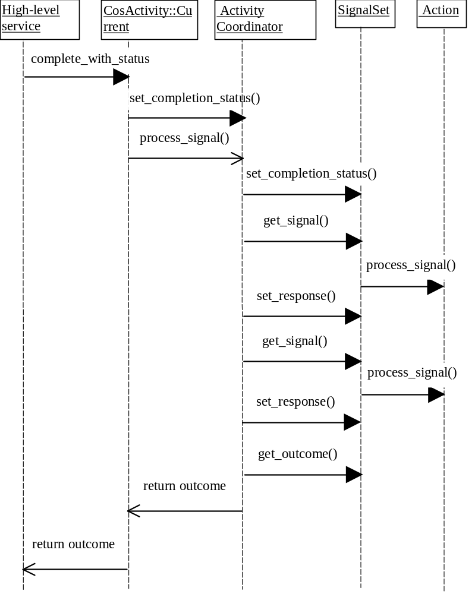
Figure 9, Completing an Activity using SignalSets and Actions.

Definition of Terms
Action
When an Activity require Signal processing, Actions will be invoked with the specified Signal.
Activity
An activity is a unit of (distributed) work that may, or may not be transactional. During its lifetime an activity may have transactional and non-transactional periods.
ActivityCoordinator
The coordinator is responsible for coordinating the interactions between Activities through Signals and Actions.
Activity Context
The activity information associated with a specific thread.
Child activity
An activity that has been created within the scope of another activity.
Compensation
An activity that can be used to return the state of the system to application specific consistency.
Current
This interface provides operations which allow the demarcation of Activity scope. In addition, it provides interfaces for coordinating the Actions of the current Activity.
Parent activity
An activity that has child activities.
PropertyGroup
A tuple-space for specifying application specific logic for coordinating and controlling the behaviour of activities.
Recovery
A series of actions for restoring the state of the system to application specific consistency.
Root activity
An activity that does not occur within the scope of another activity.
Sibling
A child activity.
Signal
An Activity may enable Signal objects to be transmitted to other Activities to inform them about application specific events. Application specific information (e.g., about how the Activity terminated) is encoded within the Signal.
SignalSet
Each Signal is associated with a specific SignalSet. A SignalSet represents the set of Signals that are required to achieve some goal, e.g., an OTS SignalSet may contain prepare/commit/rollback/forget/commit_one_phase Signals. Actions register interest in receiving Signals from a given SignalSet.
Transaction
An Object Transaction Service transaction.

References
[1] R. Soley (ed.), Object Management Architecture Guide, Third Edition, Wiley, June 1995.
[2] OMG, The Common Object Request Broker: Architecture and Specification, Revision 2.1, August 1997, OMG document formal/97-09-01.
[3] OMG, CORBAservices: Common Object Services Specification, Updated July 1997, OMG document formal/97-07-04.
[4] OMG, Meta Object Facility (MOF) Specification, October 1997, OMG document ad/97-10-02.
[5] OMG, Meta Object Facility (MOF) Appendices, October 1997, OMG document ad/97-10-03.
[6] OMG, Object Constraint Language Specification, Revision 1.1, September 1997, OMG document ad/97-08-08.
[7] C. T. Davies, “Data processing spheres of control”, IBM Systems Journal, Vol. 17, No. 2, 1978, pp. 179-198.
[8] J. J. Halliday, S. K. Shrivastava, and S. M. Wheater, “Implementing Support for Work Activity Coordination within a Distributed Workflow System”, Proceedings of the Third International Conference on Enterprise Distributed Object Computing (EDOC ’99), September 1999, pp. 116-123.

